

**FACULTY OF HEALTH SCIENCES**

**UNDERSTANDING PALLIATIVE CARE PATIENTS' EXPERIENCES WITH ALTERNATIVE AND COMPLEMENTARY PAIN MEDICATIONS**

**BY**

**Mwali Ivy Nekesa**

**U29/136938/2019**

**A dissertation submitted in partial fulfillment of the requirements for the Degree of Bachelor of Pharmacy, University of Nairobi**

# DECLARATION OF ORIGINALITY

|  |  |
| --- | --- |
| STUDENT | Mwali Ivy Nekesa |
| REG NUMBER | U29/136938/2019 |
| FACULTY | Health sciences |
| PROGRAMME | Bachelor of Pharmacy |
| TITLE | Understanding palliative care patients' experiences with alternative and complementary pain medications |

DECLARATION

I declare that this dissertation is my original work and it has not been submitted anywhere else, for examination, award of degree, or publication. Where other people's work or my work has been used, this has been properly acknowledged and referenced by the University of Nairobi requirements.

I understand what plagiarism is, and I am fully aware of the University's policy in relation to plagiarism.

I have not sought or used the services of any professional agencies to produce this work.

I have not allowed and shall not allow anyone to copy my work with the intention of passing it off as his/her work.

I understand that any false claim in respect of this work shall result in disciplinary action in accordance with the university’s plagiarism policy.

Sign …………………………………… Date ……………………………………………

# APPROVAL BY SUPERVISOR

I confirm that the above-named student wrote this dissertation, which has been submitted with my approval as the supervisor.

Name:



Sign …………………………………… Date …………18th…June…2025…………………………

Table of Contents

DECLARATION OF ORIGINALITY i

APPROVAL BY SUPERVISOR ii

LIST OF TABLES 4

LIST OF FIGURES 5

ABBREVIATIONS AND ACRONYMS 6

ABSTRACT 7

CHAPTER ONE: INTRODUCTION 8

1.0 Background Information 8

1.2 Statement of the Problem 11

1.3 Justification 12

1.4 Research Questions 13

1.5 Objectives 14

1.5.1 General Objective 14

1.5.2 Specific Objectives 14

2.0 CHAPTER TWO: LITERATURE REVIEW 14

2.1 Introduction to Literature Review 14

2.2 Theoretical Framework 14

2.3 Empirical Evidence on CAM Use in Palliative Care 15

2.3.1 Prevalence and Patterns of CAM Use 15

2.3.2 Types of CAM Utilized 15

2.3.3 Perceived Benefits and Effectiveness 16

2.4 Barriers to CAM Integration in Palliative Care 16

2.5 Socioeconomic and Cultural Influences 16

2.6 Relationship Between CAM Use and Pain Management Outcomes 17

2.7 RESEARCH GAP 17

3.0 CHAPTER THREE: METHODOLOGY 19

3.1 Study Site 19

3.2 Study Design 19

3.3 Study Population 19

3.3.1 Inclusion Criteria 19

3.3.2 Exclusion Criteria 19

3.4 Sample Size Determination 19

3.5 Sampling Method 20

3.5.1 Recruitment Strategy 21

3.6 Laboratory Procedures 22

3.7 Data Management 23

3.8 Limitations of the Study 23

3.9 Data Analysis and Presentation 24

3.9.1 Qualitative Analysis 24

3.10 Ethical Considerations 24

3.10.1 Ethical Framework and Principles 24

3.10.2 Benefits and Risks for Participants 25

3.10.3 Information Disclosure to Participants 25

3.10.4 Incentives and Remuneration 25

3.10.5 Confidentiality and Data Protection 26

3.10.6 Ethical Considerations for Human Subjects 26

3.10.7 Informed Consent Process 26

3.10.8 Inclusion of Special Populations 26

3.10.9 Institutional Ethical Approval 27

4. CHAPTER FOUR: RESULTS 27

4.1 Introduction 27

4.2 Participant Characteristics 28

Presentation of figures 32

Figure 4.3.1: Age Distribution of CAM Users 32

Figure 4.3.2: Age Distribution of CAM Users 33

Figure 4.3.3: Thematic Distribution of Patient Experiences 34

Figure 4.3.4: Top Barriers to CAM Access 35

Figure 4.3.5: Most Commonly Used CAM Types 36

Figure 4.3.6: Perceived CAM Effectiveness 37

4.4 Inference: Bivariate Analysis 38

4.5 Multivariate Analysis 40

4.6 DISCUSSION 43

4.6.1 Introduction 43

4.6.2 Understanding Patient Experiences in CAM 43

Specific objective 1: Prevalence and patterns of CAM use 44

Specific objective 2: Perceived effectiveness and satisfaction 44

Specific objective 3: Disclosure behaviour and predictors 45

Specific objective 4: Barriers, safety, and integration 45

4.6.3 How findings fit (or don’t) into existing literature; novelty and confirmation 45

4.6.4 Significance for theory and practice 46

4.6.5 Hypotheses: 47

4.6.6 Outstanding questions and issues raised by the analysis (what we didn’t fully resolve) 47

4.6.7 Limitations of the study and mitigations 48

4.6.8 Concluding synthesis, significance, and next steps 48

CHAPTER FIVE: CONCLUSIONS AND RECOMMENDATIONS 49

5.1 General conclusion (overall objective) 49

5.1.1 Conclusions by specific objectives 49

Objective 1: Prevalence and patterns of CAM use 49

Objective 2: Perceived effectiveness and satisfaction 50

Objective 3: Disclosure behaviour and predictors 50

Objective 4: Barriers, safety concerns, and integration prospects 51

5.1.2 Methodological critique: Transparency to strengthen credibility 52

Key methodological critiques and mitigating actions: 52

5.1.3 Final synthesis: what we can responsibly conclude now 53

5.2 RECOMMENDATIONS 54

A. Recommendations mapped to each objective 54

B. Practice & policy (system-level) recommendations 56

C. Research agenda: short, medium, and long term 57

D. Implementation and evaluation: Pragmatic pilot plan (6–12 months) 58

E. Stakeholder, ethical & regulatory recommendations 58

WORK PLAN 60

BUDGET 61

References (Harvard Style) 62

APPENDICES 64

Appendix I: Questionnaire 64

# LIST OF TABLES

|  |  |  |
| --- | --- | --- |
| **Table** | **Title** | **Page** |
| Table 1.1 | Burden of Life-Limiting Illnesses in Kenya (2025 MoH and KNBS Data) | 2 |
| Table 4.1 | Sociodemographic and Clinical Characteristics of Participants (n = 13) | 17 |
| Table 4.2 | Association between Gender and CAM Use | 24 |
| Table 4.3 | Association between Education Level and Disclosure of CAM Use | 24 |
| Table 4.4 | Association between Perceived Effectiveness of CAM and Disclosure | 24 |
| Table 4.5 | Logistic Regression Analysis of Predictors of CAM Use | 26 |
| Table 4.6 | Logistic Regression Analysis of Predictors of CAM Disclosure | 26 |

# LIST OF FIGURES

|  |  |  |
| --- | --- | --- |
| **Figure** | **Caption** | **Page** |
| Figure 4.3.1 | Age Distribution of CAM Users | 20 |
| Figure 4.3.2 | Age Distribution of CAM Users | 20 |
| Figure 4.3.3 | Thematic Distribution of Patient Experiences | 21 |
| Figure 4.3.4 | Top Barriers to CAM Access | 21 |
| Figure 4.3.5 | Most Commonly Used CAM Types | 22 |
| Figure 4.3.6 | Perceived CAM Effectiveness | 23 |

# ABBREVIATIONS AND ACRONYMS

|  |  |
| --- | --- |
| Abbreviation | Full Meaning |
| CAM | Complementary and Alternative Medicine |
| CIOMS | Council for International Organizations of Medical Sciences |
| GDPR | General Data Protection Regulation |
| HBM | Health Belief Model |
| ICF | Informed Consent Form |
| IERC | Institutional Ethics Review Committee |
| IRB | Institutional Review Board |
| NSAIDs | Non-Steroidal Anti-Inflammatory Drugs |
| NVivo | Qualitative Data Analysis Software |
| SPSS | Statistical Package for the Social Sciences |

# OPERATIONAL DEFINITION OF TERMS

**CAM** - Complementary and Alternative Medicine: non-conventional therapies used alongside or instead of standard medical care (e.g., herbal medicine, massage, prayer).

**Palliative care** - Care focused on improving quality of life for patients with life-limiting illness by managing pain and other physical, psychosocial and spiritual needs.

**Herbal medicine** - Therapeutic use of plant preparations (teas, decoctions, poultices) used by patients to relieve symptoms; common in Kenyan palliative populations.

**Perceived effectiveness** - Patient’s subjective judgement of how much a therapy reduced symptoms or improved wellbeing; a key predictor of disclosure in this study.

**Disclosure** - Patient informing a clinician about CAM use; disclosure was ~50% in this CAM-engaged sample.

**Integrative palliative care** - Evidence-informed blending of conventional and low-risk CAM modalities to meet holistic patient needs.

**Herb–drug interaction** - Biological interaction between herbal products and pharmaceuticals that can alter safety or efficacy.

**Biopsychosocial model** - Framework viewing pain and illness as products of biological, psychological, and social factors.

**Health Belief Model (HBM)** - A behavioral model that explains health actions by perceived severity, benefits, barriers, cues to action, and self-efficacy.

**Thematic analysis** - Qualitative method for identifying and analyzing patterns in interview data (used via NVivo in this study).

**Purposive sampling** - Non-probability selection of participants for information richness rather than statistical representativeness.

**NVivo** - Qualitative data analysis software used to code transcripts and build themes.

# ABSTRACT

**Background:** Palliative care improves quality of life for patients with life-limiting illnesses by addressing pain, psychosocial distress, and spiritual needs. Although conventional pharmacological treatments remain central, they often carry adverse effects, diminishing efficacy, and risk of dependency. Consequently, many patients turn to complementary and alternative medicine (CAM) as an adjunct to conventional care. Despite growing global and local CAM use, little is known about Kenyan palliative patients’ experiences, perceived benefits, disclosure patterns, and barriers to integration into mainstream care.

**Objective:** The study aimed to explore patient experiences with CAM in a tertiary palliative care setting, focusing on prevalence, patterns of use, perceived effectiveness, disclosure behaviors, and barriers to safe integration.

**Methods:** A mixed-methods descriptive study was conducted among 13 adult palliative care patients at Kenyatta National Hospital. Quantitative data were collected through structured questionnaires and analyzed using descriptive statistics, bivariate analyses (χ² tests), and multivariate logistic regression to identify independent predictors of CAM use and disclosure. Qualitative data from semi-structured interviews were thematically analyzed to capture patient narratives and lived experiences.

**Results:** CAM use was nearly universal (92.3%), with herbal remedies, massage, and spiritual practices being most common. Over 58% rated CAM as “very effective”, while an additional 16.7% rated it as “somewhat effective.” Disclosure rates were mixed (≈50%), with perceived effectiveness emerging as the strongest independent predictor of disclosure (OR=14.1, p<0.05). Education level also increased the odds of disclosure, while age was inversely related. Thematic analysis clustered patient experiences into three domains: (i) perceived relief and cultural resonance, (ii) barriers such as cost, limited access, and fear of disclosure, and (iii) integration needs, where patients expressed a desire for combined biomedical-CAM care.

**Conclusion:** The study demonstrates that CAM is central to the lived experience of palliative care patients in Kenya, valued for its perceived effectiveness and cultural familiarity. However, under-disclosure, safety concerns, and lack of structured integration remain significant challenges. So, in recommendation, Healthcare providers should routinely screen for CAM use in a non-judgmental manner, integrate low-risk modalities into care, and provide tailored education for vulnerable groups. Policy makers should establish national CAM safety and integration guidelines, while future research should include larger, representative Specific objective 4: Barriers, safety, integration, 45and cost-effectiveness of common CAM therapies.

# CHAPTER ONE: INTRODUCTION

## 1.0 Background Information

When someone is diagnosed with a terminal illness, palliative care becomes an important source of support. The overarching goal of palliative care is to improve the quality of life for patients and families by controlling distressing symptoms such as pain and accommodating their emotional, psychological, and spiritual needs ([Lin et al., 2023](https://doi.org/10.1186/s12906-023-03859-3)). Pain management is critical, as uncontrolled pain can significantly impact a person's physical well-being and enjoyment of life ([Dingley et al., 2021](https://doi.org/10.1177/26323524211051753)). Conventional medications: opioids and non-steroidal anti-inflammatory drugs (NSAIDs) have been the preferred methods of treating pain for palliative care has For over 10 years, both patients and health care practitioners have been more aware of their respective disadvantages, including unwanted side effects, nausea, sedation, constipation, and potential for dependency. This awareness has led to an increase in interest concerning alternative and complementary medicine (CAM) ([Wode et al., 2023](https://doi.org/10.1093/oncolo/oyad084)). CAM is a broad term encompassing a wide range of non-conventional modalities, alternative medicines, which include acupuncture, herbal medicine, massage, energy medicine (such as Reiki), and mindfulness and meditation exercises ([Łukasik et al., 2024](https://www.journals.viamedica.pl/palliative_medicine_in_practice/article/view/98210)).

In the past twenty years, there has been a paradigm shift towards "integrative palliative care," an approach that combines conventional treatment and CAM modalities into a cohesive whole, utilizing a person-centered philosophy of care. Many palliative care patients are already using CAM; studies estimate that between 30% and 90% of palliative care patients use some form of alternative medicine to augment pain management (Fan et al., 2021). Despite their immense use, there is currently a lack of quality and conclusive evidence-based research regarding the effectiveness, safety, and patient experience of these therapies ([Fan et al., 2021](https://doi.org/10.1016/j.ctim.2021.102687)). Why are people using CAM in palliative care? Part of the answer involves understanding that pain is not only a sensory experience (Frass et al., 2020). Why do individuals pursue CAM in palliative care? The acceptance of CAM therapy lies in the recognition that pain is not only a physical experience. The biopsychosocial model helps explain that pain is influenced by our perceptions, feelings, and social context ([Gatchel et al., 2007](https://doi.org/10.1016/j.pain.2006.11.008)). CAM therapies are often oriented towards addressing some of the complexities of pain, for example, by providing relaxation, lowering anxiety, and improving overall well-being ([Towler et al., 2020](https://doi.org/10.1016/j.jpainsymman.2019.09.023)). For example, some evidence suggests acupuncture can impact human pain perception by stimulating the body to release natural pain relievers (endorphins) and altering the pain messages that are sent through our nervous system ([Mao et al., 2019](https://doi.org/10.1200/JCO.18.01755)). Additionally, aromatherapy has been associated with lower levels of anxiety and nausea, making patients feel more comfortable ([Armstrong et al., 2019](https://doi.org/10.1177/0269216319825973)).

However, there are some barriers to incorporating CAM into standard palliative care. One important barrier is that CAM, as a whole, lacks coherent standards or regulations for many CAM products and practices. This raises legitimate concerns about the quality and dosage of herbal remedies, as well as potential interactions with conventional medications ([Gupta et al., 2022](https://doi.org/10.1016/j.jep.2021.114561)). Furthermore, many practitioners in medicine and nursing have little or no training in CAM, resulting in skepticism or reluctance to promote CAM therapies ([Koenig et al., 2018](https://doi.org/10.1097/NMD.0000000000000795)). Another barrier is the communication breakdown; patients rarely tell their health care team that they are using CAM therapy for their pain, often due to fear of disapproval ([Wode et al., 2023](https://doi.org/10.1093/oncolo/oyad084)).

Cultural factors and economic structures also shape how individuals use CAM as part of palliative care. In many other global cultures, traditional medicine, including herbal medicines and spiritual healing, has always been part of health care and effective communication ([Lin et al., 2023](https://doi.org/10.1186/s12906-023-03859-3)). while many Western medical systems have relied too much on and are unwilling to treat patients in a CAM context based on the traditional regime and arranged evidence (Frass et al., 2020).

This study aims to fill the gaps in our knowledge regarding non-pharmaceutical therapies in the context of palliative care, ultimately exploring the phenomenological experiences of palliative patients who engage in complementary and alternative medicine (CAM) therapies to manage their pain. By uncovering patient narratives and experiences, we can understand how the patients see themselves in the process of implementing CAM, their motivations and results, and how, if, and when they can see CAM integrated into their overall pain reduction techniques. Additionally, the study can help us understand the barriers and facilitators of CAM use in the palliative care space based on patients' experiences and provide evidence-based rationale and recommendations to encourage best practices from an integrative health care perspective. Most importantly, this research aims to add to the palliative care and pain management conversation. By exploring what we know and what we don't know, palliative care and pain management practitioners, policy makers, and the patients they serve can use the outcomes of this study to inform their next steps for incorporating CAM. This research is intended to advocate for a more patient-centered approach that enhances, or at a minimum, maintains quality of life for patients with terminal illnesses([Łukasik et al., 2024](https://www.journals.viamedica.pl/palliative_medicine_in_practice/article/view/98210)).

Palliative care in Kenya, as outlined in the MoH's 2021–2030 Policy, is an approach that enhances the quality of life for patients and their families facing life-threatening illnesses through comprehensive symptom management, psychological support, and spiritual care. In line with the WHO's 2020 definition and the 2010 Constitution's Article 43 right to health, it addresses the triple burden of infectious diseases (HIV/AIDS), non-communicable diseases (cancer), and injuries (neurological trauma). However, as the 2025 Global Atlas ranks Kenya at 4/5 for development (indicating advanced integration but notable equity gaps), access remains uneven: 800,000 people require services annually, yet only 14,552 receive them, mainly in urban centers like KNH, which serves over 600 patients monthly amid a doctor-patient ratio of 1:5,000 (WHO, 2025). Since devolution began in 2010, county-level services have been promised, but arid regions like Garissa report no units, forcing patients to travel 500 km for morphine and often relying on local waganga.

**Table 1.1: Burden of Life-Limiting Illnesses in Kenya (2025 MoH and KNBS Data)**

|  |  |  |  |  |
| --- | --- | --- | --- | --- |
| **Illness** | **Annual New Cases/Prevalence** | **Annual Deaths** | **Pain Prevalence (%)** | **Key Kenyan Drivers** |
| Cancer | 51,000 | 37,000 | 90 | Late diagnosis (60% stage IV at KNH), HPV/HBV, tobacco (15%) |
| HIV/AIDS | 1.3 million PLHIV | 20,000 | 75 | Stigma, neuropathy from ART, opportunistic infections |
| Organ Failure (Renal/Hepatic) | 25,000 end-stage | 15,000 | 85 | Diabetes (9%), hypertension (27%), schistosomiasis |
| Neurological Disorders | 12,000 advanced | 8,000 | 80 | Stroke from untreated HTN, trauma in jua kali workers |

### 1.2 Statement of the Problem

Pain is frequently one of the biggest obstacles for people receiving palliative treatment. Unfortunately, traditional medical treatment typically does not provide adequate control of the pain, and the medical treatments selected often include debilitating side effects ([Dingley et al., 2021](https://doi.org/10.1177/26323524211051753); [Wode et al., 2023](https://doi.org/10.1093/oncolo/oyad084)). Potent and non-potent analgesics, including opioids and non-steroidal anti-inflammatory agents, are the staples in the management of pain ([Lin et al., 2023](https://doi.org/10.1186/s12906-023-03859-3)), but they are sometimes hampered by serious side effects like nausea, sedation, constipation, and worrisome consequences of becoming dependent upon a medication (Guziak et al., 2024). Therefore, it is understandable that there is increasing interest in complementary and alternative medicine (CAM) patients are looking for other options or even alternatives to assist them with their pain in palliative care ([Lin et al., 2023](https://doi.org/10.1186/s12906-023-03859-3)).

Recent studies report that many patients at the end of life are already using CAM to relieve pain and enhance their quality of life. For example, one study in Taiwan found that approximately 88% of terminally ill patients had utilized CAM at some point, with some even stopping conventional treatments because they felt that alternative therapies were working better ([Lin et al., 2023](https://doi.org/10.1186/s12906-023-03859-3)). Other studies revealed that CAM therapies (e.g., acupuncture, massage, music therapy) are also being used in hospice and often with mixed but sometimes supportive effects on reducing pain, anxiety, or depression ([Dingley et al., 2021](https://doi.org/10.1177/26323524211051753)). Notwithstanding, many patients conceal their CAM use from their physician, often from fear of the physician's opinion or a possibility of competing suggestions ([Wode et al., 2023](https://doi.org/10.1093/oncolo/oyad084)).

This raises some very serious questions. One important concern is the absence of clear guidelines and scientific evidence to support the safety and efficacy of many CAM therapies ([Dingley et al., 2021](https://doi.org/10.1177/26323524211051753)While certain therapies such as acupuncture and cannabinoids seem to be promising for pain relief based on evidence, most others are still highly contested based on unreliable study outcomes or size of clinical trials ([Łukasik et al., 2024](https://www.journals.viamedica.pl/palliative_medicine_in_practice/article/view/98210)). The lack of transparency between patients and their medical teams regarding CAM use is also problematic since it can prevent open discussion about harmful outcomes of interactions between treatments or delays in needed conventional treatment ([Wode et al., 2023](https://doi.org/10.1093/oncolo/oyad084)).

Access to CAM and acceptance also vary considerably based on cultural norms, means based on the person's financial situation, and local and regional health care policies ([Dingley et al., 2021](https://doi.org/10.1177/26323524211051753)). Although CAM is widely accepted in some places in the world, for others, especially when resources are limited, using CAM formally in palliative care may be more complicated to accept, with regulatory policies and insurance coverage being a major barrier.

Because so many palliative care patients use CAM, it is essential to conduct more research into their experiences, beliefs about the therapies, and resultant outcomes. We need to fill that knowledge gap. These results will enable clinicians to provide better advice: evidence-based approaches that respect the patient's preferences and are safe and effective ([Lin et al., 2023](https://doi.org/10.1186/s12906-023-03859-3)). Having strategies in place to facilitate open, truthful conversations with patients about their CAM use is also essential to optimizing pain management strategies in palliative care ([Wode et al., 2023](https://doi.org/10.1093/oncolo/oyad084)).

This study, therefore, aims to explore the lived experiences of palliative care patients who used CAM for their pain. We want to find out the patients' rationales, the perceived benefits and harms, obstacles to using CAM approaches for their pain, and the effects on their overall situation. We hope that identifying these factors will result in important knowledge being made available to inform future pain management strategies that integrate both conventional and complementary therapies in a patient-centered and holistic approach ([Dingley et al., 2021](https://doi.org/10.1177/26323524211051753)).

### 1.3 Justification

The reasons for this study were based on two intersecting realities in current palliative care: a growing number of patients in palliative care are using complementary and alternative medicine (CAM) to manage their symptoms; therefore, there is a need to examine these therapies and their effectiveness. Do they work? Are they safe? How do they become part of normal health care? It is known that standard pain treatments, while common, can sometimes cause side effects that affect a person's well-being and quality of life (Guziak et al., 2024). So, it's understandable that people might seek out other options like acupuncture, herbal medicine, aromatherapy, or even cannabinoids, hoping to find relief and feel more in control of their bodies ([Lin et al., 2023](https://doi.org/10.1186/s12906-023-03859-3)).

However, there's a disconnect. Many doctors and nurses don't have enough information about CAM, which can lead to inconsistent advice and potentially put patients at risk ([Wode et al., 2023](https://doi.org/10.1093/oncolo/oyad084)). Adding to this, studies show that many patients hesitate to even mention they're using alternative medicine, often because they worry their doctor might disapprove or be biased against it ([Dingley et al., 2021](https://doi.org/10.1177/26323524211051753)). This silence isn't helpful. It clearly shows the need to foster more open conversations and develop clear, reliable guidelines so that if patients choose CAM, it can be used safely and effectively alongside their conventional care.

There's also a real need for better research. While some studies suggest CAM can be beneficial, there is a lack of large-scale, high-quality trials needed for these therapies to be widely accepted and integrated ([Łukasik et al., 2024](https://www.journals.viamedica.pl/palliative_medicine_in_practice/article/view/98210)). Getting a clear picture of patients' own experiences, what works for them, what doesn't, and why is crucial. This kind of understanding can directly inform how healthcare is practiced and how policies are made.

This study directly addresses this gap by listening to the narratives of palliative care patients who use CAM for pain. By gathering their stories through in-depth qualitative methods, we can build a much richer understanding of their motivations, experiences, and challenges. These findings were invaluable in creating healthcare approaches that respect diverse patient needs and offer care that is both holistic and genuinely patient-centered.

### 1.4 Research Questions

1. What were the experiences of palliative care patients in using complementary and alternative medicine (CAM) for pain management?
2. What were the perceived benefits and challenges associated with CAM use among palliative care patients?
3. How did palliative care patients decide to incorporate CAM into their pain management regimen?
4. What were the key barriers to CAM disclosure and integration within conventional palliative care settings?
5. How did healthcare providers perceive and respond to CAM usage among palliative care patients?
6. What were the most commonly used CAM therapies in palliative care, and how do patients assess their effectiveness?
7. How can an evidence-based framework be developed to integrate CAM into standard palliative care practices?

### 1.5 Objectives

### 1.5.1 General Objective

Sought to explore and understand the experiences of palliative care patients with alternative and complementary pain medications, while identifying the factors that influence their choices, perceptions, and outcomes regarding pain management.

### 1.5.2 Specific Objectives

Specifically, this study sought to:

1. Identify the types of complementary and alternative pain medications used by palliative care patients.
2. Assess the perceived effectiveness and benefits of CAM in pain management among palliative care patients.
3. Determine the barriers and challenges faced by palliative care patients in accessing and using CAM.

# 2.0 CHAPTER TWO: LITERATURE REVIEW

## 2.1 Introduction to Literature Review

Recently, there has been a growing conversation about incorporating complementary and alternative medicine (CAM) into palliative care. Since the main goal of palliative care is to boost the quality of life for people facing serious illnesses, it's natural that CAM therapies are being looked at as ways to help manage pain and other symptoms, either alongside or maybe even instead of the usual treatments. This literature review examines the research findings on CAM in palliative care, its application, effectiveness, patient perceptions, and the underlying concepts that may influence the adoption of these approaches.

## 2.2 Theoretical Framework

So, why might someone dealing with a serious illness decide to try CAM? The use of CAM in palliative care can be analyzed through a few different conceptual models. Take the Health Belief Model (HBM), for instance. This model suggests that a person's decision often comes down to a few key things: how serious they think their pain is, whether they believe CAM could make a difference, what obstacles they face (like cost or just finding a practitioner), and what specific events or advice prompt them to consider it ([Rosenstock, 1974](https://doi.org/10.1177/109019817400200403)). Then there's the Integrative Medicine Model, which advocates for a more holistic approach, seeking to combine the benefits of conventional medical treatments with alternative therapies that have shown promise through research (Maizes et al., 2009). The Biopsychosocial Model of Pain is also considered. This is crucial because it reminds us that pain isn't just a physical signal; our thoughts, emotions, and social situations profoundly shape how one feels pain and copes with it([Gatchel et al., 2007](https://doi.org/10.1016/j.pain.2006.11.008)). Examining these various frameworks helps us appreciate the numerous complex factors that can lead a patient towards CAM.

## 2.3 Empirical Evidence on CAM Use in Palliative Care

### 2.3.1 Prevalence and Patterns of CAM Use

Looking at the numbers, studies show that quite a few palliative care patients are using CAM, though how many exactly can vary a lot. It seems to depend on the country, the specific illness, and even how researchers decide to define "CAM." For instance, one cross-sectional study in Taiwan reported a surprisingly high usage rate, with 88% of terminally ill patients staying in hospice having used CAM at some point ([Lin et al., 2023](https://doi.org/10.1186/s12906-023-03859-3)). Broader reviews looking at cancer patients (many of whom end up in palliative care) find rates all over the map, sometimes spanning from 30% to as high as 90%, often heavily shaped by local culture, availability, and whether practices like prayer are included (Frass et al., 2020). Even in some Western countries, where conventional medicine is the norm, usage rates can reach up to 50%, showing this is a pretty significant global trend ([Wode et al., 2023](https://doi.org/10.1093/oncolo/oyad084)).

### 2.3.2 Types of CAM Utilized

The CAM therapies people chose were quite varied. Some of the most common ones popping up in studies include acupuncture, herbal remedies, aromatherapy, massage, and prayer. Specific types often depended on cultural context; for example, traditional herbal medicine is particularly common in East Asian settings, where certain formulations have shown potential for pain relief ([Fan et al., 2021](https://doi.org/10.1016/j.ctim.2021.102687)). Research suggests specific benefits for certain modalities. Studies indicate acupuncture might be helpful for pain related to cancer ([Towler et al., 2020](https://doi.org/10.1016/j.jpainsymman.2019.09.023)), and aromatherapy, using essential oils, has been linked to lower levels of anxiety and nausea in palliative settings ([Armstrong et al., 2019](https://doi.org/10.1177/0269216319825973)).

### 2.3.3 Perceived Benefits and Effectiveness

From the patients' point of view, many who tried CAM said it made a positive difference; they reported better pain control, feeling better emotionally, and generally having a higher quality of life. For example, an integrative review by [Dingley and colleagues (2021)](https://doi.org/10.1177/26323524211051753) highlighted studies where therapies like prayers and massage helped ease anxiety and depression symptoms for hospice patients. Indeed, national surveys have shown significant employment of CAM therapists in US hospices, with figures around 74% employing massage therapists and 53% prayer therapists. It's worth remembering, though, that the evidence isn't always crystal clear or consistent across all CAM types. For some therapies, studies haven't reached firm conclusions, often because of limitations in research design or small sample sizes ([Łukasik et al., 2024](https://doi.org/10.5603/pmp.98210)).

## 2.4 Barriers to CAM Integration in Palliative Care

Even with growing interest and use, smoothly fitting CAM into standard palliative care runs into several big obstacles. A major issue is the lack of consistent methods and robust scientific proof to confirm how well many CAM practices work and how safe they are ([Wode et al., 2023](https://doi.org/10.1093/oncolo/oyad084)). Keeping quality consistent is another challenge, especially for things like herbal products, where standardization can be difficult ([Gupta et al., 2022](https://doi.org/10.1016/j.jep.2021.114561)). From the healthcare provider side, many doctors and nurses just haven't had much training in CAM, which can make them skeptical or simply hesitant to even bring up these options ([Koenig et al., 2018](https://doi.org/10.1097/NMD.0000000000000795)). The issue of communication breakdowns is also relevant; some studies have estimated the ratio of patients who do not tell their medical team about their CAM use to be significant (e.g., 50 - 70% in certain populations), often because of fears of being assessed, and/or rejected. Not just that, in other areas of healthcare, non-disclosure of information through effective communication is an issue as there are risks of adverse drug interactions, or misinterpreting care in general ([Dingley et al., 2021](https://doi.org/10.1177/26323524211051753); [Wode et al., 2023](https://doi.org/10.1093/oncolo/oyad084)).

## 2.5 Socioeconomic and Cultural Influences

We also need to look at how culture and finance are impacting CAM use; research suggests that individuals from non-Western countries have a higher likelihood of using herbal medicines or culturally acceptable healers ([Gupta et al., 2022](https://doi.org/10.1016/j.jep.2021.114561)). Money also plays a role, as insurance typically won't reimburse for CAM use; the price tag on CAM interventions can be a barrier, especially for individuals with a lower income ([Lin et al., 2023](https://doi.org/10.1186/s12906-023-03859-3)). Personal religious or spiritual beliefs can also sway preferences, perhaps leading some patients towards spiritual healing methods, which are sometimes categorized alongside CAM ([Koenig et al., 2018](https://doi.org/10.1097/NMD.0000000000000795)).

## 2.6 Relationship Between CAM Use and Pain Management Outcomes

Finally, a few studies have tried to see if using CAM directly leads to better pain management results in palliative care. For instance, a randomized controlled trial by [Mao and colleagues (2019)](https://doi.org/10.1200/JCO.18.01755) investigated acupuncture for cancer pain and found that patients using it needed significantly less opioid medication (though other studies comparing acupuncture to sham treatments for different pain types have yielded mixed results on opioid dosage reduction). Similarly, awareness practices have been connected to people reporting that they can handle pain better and feel less psychological distress. Research suggests mindful acceptance techniques can significantly reduce negative feelings associated with pain (effect size d=1.51 for heat pain) and even decrease objective measures of the brain's pain response by around 26% compared to unawareness reactions ([Zeidan et al., 2020](https://doi.org/10.1016/j.jpain.2019.11.008)). These studies hint at potential direct benefits, although more large-scale, rigorous research is certainly needed to confirm these links across different CAM modalities and patient populations.

## 2.7 RESEARCH GAP

Despite the growing use of complementary and alternative medicine (CAM) among palliative care patients, significant gaps remain in the academic and clinical understanding of how these therapies are experienced, perceived, and integrated into care.

First, while numerous studies have documented the prevalence and types of CAM therapies used in palliative care [(Lin et al., 2023](https://doi.org/10.1186/s12906-023-03859-3); [Wode et al., 2023)](https://doi.org/10.1093/oncolo/oyad084), the majority focus on quantitative metrics and overlook the subjective experiences of patients. There is limited qualitative research that captures the personal narratives of individuals using CAM to manage pain, leaving a void in our understanding of the psychosocial and emotional dimensions of CAM use in end-of-life care.

Although some evidence supports the clinical benefits of CAM, such as acupuncture and aromatherapy in reducing pain and anxiety [(Mao et al., 2019](https://doi.org/10.1200/JCO.18.01755); [Armstrong et al., 2019)](https://doi.org/10.1177/0269216319825973), there is still insufficient data on patients’ perceptions of effectiveness. Few studies explore whether patients themselves feel that CAM therapies have improved their pain management or quality of life, which is a critical component in the evaluation of holistic care approaches.

It seems like a lot of patients just aren't telling their doctors or nurses about the complementary or alternative therapies they're using, often because they're worried about getting disapproved of or meeting skepticism ([Wode et al., 2023](https://doi.org/10.1093/oncolo/oyad084)). But right now, enough is not known about *why* this communication gap exists, or what it means for keeping patients safe, building trust with their care team, and making sure their care is seamless. Figuring out these dynamics is important if ways are created for patients and providers to talk openly and honestly.

Things like culture and a person's financial situation also play a role in whether a patient will use CAM. However, there hasn't been much research looking into exactly *how* these factors affect whether people can access CAM, what therapies they prefer, or even how legitimate they view these options, especially when considering different groups of people ([Gupta et al., 2022](https://doi.org/10.1016/j.jep.2021.114561); [Koenig et al., 2018](https://doi.org/10.1097/NMD.0000000000000795)). Because of the lack of this kind of culturally aware research, it's hard to apply what is known across diverse communities and healthcare environments.

Another missing piece is a clear, agreed-upon way to bring CAM into regular palliative care. While some researchers suggest taking a more holistic approach (Frass et al., 2020), there aren't many practical, evidence-based guides or suggestions on how to *do* it. Plus, most studies tend to focus only on cancer patients, often overlooking people with other kinds of terminal illnesses and their unique palliative care needs.

All these gaps highlight the need for more thorough research that focuses on the real, lived experiences of palliative care patients using CAM. This proposed study aims to tackle these shortcomings by digging into why patients use CAM, what they see as the benefits, the communication hurdles they face, and the barriers that stop them from accessing these therapies. The hope is that this information can help shape better, more integrated care strategies and policies down the road.

# 3.0 CHAPTER THREE: METHODOLOGY

## 3.1 Study Site

The study was conducted in **palliative care centers, hospices, and oncology units** across Kenyatta National Hospital. The sites were selected based on their accessibility, the availability of palliative care patients, and institutional willingness to participate in the study.

## 3.2 Study Design

This research adopted a **descriptive qualitative study design** to explore palliative care patients' experiences with alternative and complementary pain medications. The qualitative component involved **semi-structured interviews** and **survey questionnaires.**

## 3.3 Study Population

The study population did comprise adult patients receiving palliative care, specifically those who had either previously utilized or were currently using complementary and alternative medicine (CAM) as a method for managing pain.

### 3.3.1 Inclusion Criteria

To qualify for participation in this study, patients were to meet several criteria. Firstly, they must have been diagnosed with a terminal illness and actively receiving palliative care. Additionally, they should have employed at least one form of CAM for their pain management needs. Participants were to be at least 18 years of age and capable of providing informed consent regarding their participation in the study.

### 3.3.2 Exclusion Criteria

Several groups were excluded from this study to ensure the integrity of the findings. Patients who suffered from severe cognitive impairments that affected their ability to communicate effectively did not qualify. Furthermore, those who expressed an unwillingness to participate in the study were also excluded. Lastly, individuals who had not utilized any form of CAM in their pain management were not considered for inclusion.

## 3.4 Sample Size Determination

This study employed a descriptive qualitative research design. In qualitative research, sample size is not determined by statistical power calculations but by the principle of data saturation. Data saturation is achieved when the collection of further data does not yield new insights, themes, or perspectives relevant to the research questions (Morse, 1995; Guest, Bunce & Johnson, 2006).

A target sample size of approximately 15 participants was deemed appropriate for this study. This range was based on the following considerations:

1. **Aim of the Study**: The objective was to gain an in-depth understanding of the lived experiences of palliative care patients using complementary and alternative medicine (CAM) for pain management within the context of Kenyatta National Hospital. This required rich, detailed data from each participant rather than a large, statistically representative sample.
2. **Anticipated Saturation**: Based on the focused nature of the research questions and common practices in qualitative health research exploring patient experiences (Malterud, Siersma & Guassora, 2016), it is anticipated that a sample of the 13 participants, selected purposefully for their experience with CAM, was sufficient to achieve data saturation, capturing a range of relevant experiences and perspectives until redundancy is reached.
3. **Sampling Strategy**: Purposive sampling was used to recruit knowledgeable participants with lived experience of the phenomenon of interest (CAM for pain in palliative care). This focused strategy increased the probability of obtaining relevant data efficiently.
4. **Depth of Data Collection**: Semi-structured interviews and questionnaires provided a comprehensive investigation into each person's experiences, motivations, perceived benefits, and challenges of using CAM. A sample size of 13 participants was planned so that a sufficient amount of time and depth of engagement could be provided to each participant.
5. **Feasibility:** The planned sample size was feasible, considering about time and resources that were available to this research project, while still attending to methodological rigor.

## 3.5 Sampling Method

This study used **Purposive Sampling**, a type of non-probability sampling widely used in qualitative research. Purposive sampling entails selecting participants based on specific characteristics and knowledge relevant to the study’s aims, rather than random selection. The decision to use purposive sampling was justified in this study because it recruited individuals who had knowledge and direct experience using complementary and alternative medicine (CAM) for pain management in palliative care.

The selection process will specifically focus on achieving **diversity in CAM use** among the participants. This strategy, often related to maximum variation sampling, aims to capture a wide range of experiences and perspectives. Rather than seeking a statistically representative sample, the goal is to include palliative care patients who have utilized different types of CAM therapies (such as herbal medicine, acupuncture, aromatherapy, massage, mindfulness, etc. ) for pain relief. This approach will involve:

1. **Identification:** Potential participants meeting the inclusion criteria will likely be identified in collaboration with healthcare staff at the palliative care units within Kenyatta National Hospital.
2. **Selection for Variation:** From this pool, individuals were purposefully selected, ensuring a mix of CAM modalities used. For instance, efforts were made to recruit participants who have experience with different categories of CAM (e.g., mind-body practices, biologically based therapies, manipulative methods) to avoid overrepresentation of a single type. Information regarding the type of CAM used might be gathered during initial screening or referral.
3. **Alignment with Objectives:** This focus on diversity directly supports the study's objectives, such as identifying the range of CAM types used, assessing the varied perceived effectiveness and benefits, and uncovering the different barriers and challenges faced by patients using diverse CAM approaches.

### ****3.5.1 Recruitment Strategy****

Participants were recruited from palliative care units, hospices, and oncology wards within Kenyatta National Hospital. Recruitment was carried out in collaboration with attending healthcare staff, including nurses and palliative care physicians, who will assist in identifying eligible patients based on the study’s inclusion criteria.

The recruitment process will proceed as follows:

1. **Pre-screening by Medical Staff:**  
   Healthcare professionals were pre-screening patients under their care to identify those who met the eligibility criteria, specifically adult patients receiving palliative care who have used or are currently using complementary and alternative medicine (CAM) for pain management.
2. **Referral to Research Team:**  
   With patient permission, pre-identified eligible participants were referred to the research team. Patients will only be approached after medical staff have confirmed that they are clinically stable and willing to receive visitors.
3. **Initial Contact and Information Session:**  
   The principal investigator or trained research assistant will approach referred patients at a convenient time, explain the purpose and procedures of the study verbally and in writing, and address any questions or concerns. Ample time was given to consider participation.
4. **Voluntary Consent:**  
   Only patients who express interest and provide written informed consent were enrolled. Consent forms will clearly indicate that participation is voluntary and has no effect on the care they receive.
5. **Ethical Sensitivity in Recruitment:**  
   The recruitment process was designed to avoid exerting pressure or causing distress to vulnerable patients. Interviews will only proceed when the patient is comfortable and alert, and participation will be paused or discontinued at any point if requested by the patient.

The recruitment goal is to ensure a diverse and information-rich sample while respecting the dignity, autonomy, and well-being of all participants.

## 3.6 Laboratory Procedures

Since this is a social science-based study, no laboratory procedures were involved. However, qualitative data collection tools such as **audio recorders, transcription software, and validated survey instruments** were used to ensure data accuracy and reliability.

## Data Management

Here's how data were handled carefully: all interviews were audio recorded and then typed out word-for-word to make sure everything was captured accurately. These typed transcripts were kept safe and organized using NVivo software, which will help in sorting through the interview text to find common themes and ideas. To make sure the findings are trustworthy, a couple of cross-checking methods were used; a comparison of notes between different interviews and transcripts was done, and discussions with colleagues about the interpretations (peer debriefing)will also be done. Most importantly, to protect everyone's privacy, there won't be the use of real names; each participant will have a code name or pseudonym instead. All the digital data was kept securely on encrypted, password-protected systems that only the main research team can access. **NVivo software for Analysis:** it was used after the interview transcripts. It will help to organize the text, identify key themes, code segments of the interviews based on those themes, and explore patterns and relationships within the qualitative data.

## 3.8 Limitations of the Study

Like any study, this one has a few potential weak spots that should be kept in mind. For one, people were asked to remember their past experiences with complementary and alternative medicine (CAM), and sometimes memory can be a bit fuzzy, which could affect their answers (this is often called recall bias).

Another thing is that only patients who are willing and able to share their stories with us were included. The patients who volunteer might be different in some ways from those who don't, so the group might not perfectly represent *everyone* using CAM in palliative care (this is known as selection bias).

Also, because the focus is on specific palliative care settings here in Nairobi, the findings might not perfectly match what happens in other hospitals or regions; what works or is experienced here might not be universal (this relates to generalizability).

Finally, there's always a chance that when people answer questions, they might lean towards responses they feel are more socially acceptable or what they think the researchers want to hear, rather than purely reflecting their own beliefs or actions (this is self-reporting bias). The best was done to create a comfortable environment to minimize this, but it's something to be aware of.

## 3.9 Data Analysis and Presentation

### 3.9.1 Qualitative Analysis

**Thematic analysis** was conducted using NVivo software to identify new patterns and themes. **Grounded theory methodology** was used to develop explanations based on patient experiences.

## 3.10 Ethical Considerations

Making sure this research is ethically conducted and respectfully done is the absolute top priority. This section outlines the ethical principles that will guide the study in protecting participants, getting informed consent, keeping information private, remaining culturally sensitive, and securing official ethical approval.

### 3.10.1 Ethical Framework and Principles

The study is committed to following strict ethical standards based on respected international guidelines. At the heart of the approach are the principles from the **Declaration of Helsinki,** respecting individual rights, always aiming to do good (beneficence), acting in the best interest of participants, and ensuring fairness (justice) in how the research is conducted and its results shared. It is, however, guided by the foundational principles of the **Belmont Report**, which emphasizes the respect for persons (through recognition of autonomy, true informed consent, and protection of vulnerable populations); beneficence (maximizing potential benefits and minimizing risks); and justice (fairness regarding subjects in participant selection and research results). In addition to the Belmont principles, **CIOMS** Guidelines were followed as they offer specific guidance to ethically work with potentially vulnerable groups, and this is especially pertinent because members of the target population in this study, patients in palliative care, may require more ethical consideration because of their clinical profile. Lastly, there is a strong emphasis on the contents of privacy; however, extensive data-privacy legislation was followed, such as the General Data Protection Regulation (**GDPR**) and applicable Kenyan laws, and all personal information was kept confidential using operationalized data security measures such as encryption, data access and storage, and controlled access to the data. Collectively, these considerations will inform the foundation of the study and ensure it is legitimate, transparent, and carried out with ethical principles.

### 3.10.2 Benefits and Risks for Participants

The study is designed to offer valuable insights into how CAM is used and experienced in palliative care, potentially helping to improve clinical practice and inform policy. For those who participated, potential benefits included the chance to share their unique experiences and perspectives on using CAM for pain, contributing to a deeper understanding of patient needs. The study's findings might also lead to better palliative care services down the line and increase awareness about different CAM options for both patients and healthcare professionals. However, there will also be potential risks that were recognised. Discussing illness and pain can sometimes bring up difficult emotions, and while strong measures were taken to protect privacy, there's a very small risk of a confidentiality breach. Participation also requires time and energy, which could be burdensome for very unwell patients, and one must be culturally sensitive, given the diversity in CAM views. To manage these risks, participants were told they have the right to stop at any time without consequence, and support services information was available if anyone felt distressed.

### 3.10.3 Information Disclosure to Participants

Before anyone decides whether to join the study, it was ensured that they have all the information they need, explained clearly both verbally and in writing. They'll understand the study's purpose and relevance to palliative care, exactly what participation involves, such as interviews or questionnaires, and that joining is completely voluntary, with the freedom to withdraw later without any negative consequences for their medical treatment. It will also be explained that their personal information was kept confidential and secure, detail any potential risks involved and how they were managed, inform them about the expected time commitment and how the findings might be used, and provide contact details for both the researchers and the ethics committee should they have questions or concerns. It was ensured that every participant felt fully informed before they consented.

### 3.10.4 Incentives and Remuneration

The participants will not be receiving any financial payment for taking part in the study, as it doesn't involve a major time commitment or significant burden. However, refreshments (like a bottle of water)will be offered as a small token of appreciation for their time and contribution.

### 3.10.5 Confidentiality and Data Protection

Protecting participant confidentiality is crucial. This was achieved through several measures, including anonymization, where there were a replacement of real names were replaced with unique codes or pseudonyms so personal identities are not linked to the data. Secure storage is also key; all digital files, like recordings and transcripts, were encrypted and stored in password-protected databases. Access was limited, ensuring only the principal supervisor and authorized research staff directly involved in analysis could view the raw, identifiable data. Furthermore, all data handling and sharing will strictly adhere to compliance requirements under GDPR and relevant Kenyan data protection laws to ensure privacy standards are met.

### 3.10.6 Ethical Considerations for Human Subjects

It's important to note this study doesn't involve testing new drugs, vaccines, or medical procedures, although it does involve participants sharing personal health information and experiences. Therefore, several considerations apply: an ethical approval form was obtained from an Ethics Research Committee (ERC) before starting any data collection. The guiding principles outlined in the Declaration of Helsinki and the Belmont Report were strictly followed. Generally, children and individuals with extreme cognitive impairments will not be included, unless scientifically necessary, in which case there would be extra protection measures in place approved by the ERC, where applicable. Including consideration for the cultural appropriateness of this research means respecting local laws, customs, and traditions that may affect participation.

### 3.10.7 Informed Consent Process

A clear, written Informed Consent Form (ICF) including all aspects of this study was provided to participants with time to read and ask questions. Consent was obtained with a signature. If, for some reason, they are unable to sign, an approval from the ERC was obtained to document their verbal consent.

### 3.10.8 Inclusion of Special Populations

The study will primarily focus on adult palliative care patients, but inclusivity will also be desired. Inclusions were considered in several additional ways, such as comfort with procedures and understanding of information, which are especially important for older participants. Efforts were made to achieve gender balance among participants. In addition, the study will pay careful attention to cultural and ethnic diversification; sensitive training was given to researchers and account for differences in backgrounds. The study is committed to avoiding any discriminatory exclusion based on sex, race, ethnicity, or socioeconomic status.

### 3.10.9 Institutional Ethical Approval

To begin data collection, a complete research plan with a detailed protocol, consent forms, and ethics strategy will first be submitted to the **KNH-UoN Ethics Review Committee (IERC)**. The Committee will have to thoroughly review the research plan to ensure that it is an ethical study. At this time, the Committee will provide feedback to help with the research; once the feedback has been addressed, a formal, documented ethical clearance will be completed. The approval will ensure that the study and the study participants have followed the best possible ethical standards during research and therefore have taken measures to protect participants to the highest degree possible, as well as maintain research integrity.

# 4. CHAPTER FOUR: RESULTS

### 4.1 Introduction

This chapter presents the study findings in line with the objectives set out in the preceding sections. The results are organized to provide a clear understanding of the experiences and outcomes related to palliative care and complementary and alternative medicine (CAM). The chapter begins with a description of the study participants, outlining their sociodemographic and clinical characteristics. It then proceeds to present descriptive analyses of CAM use patterns, perceived effectiveness, disclosure practices, and barriers to integration. Subsequent sections highlight associations between key variables through bivariate analyses and further explore predictors of CAM utilization and disclosure using multivariate techniques. Together, these results provide both a quantitative overview and qualitative insights into the role of CAM in palliative care, setting the foundation for interpretation and discussion in the next chapter.

### 4.2 Participant Characteristics

**Table 4.1: Sociodemographic and Clinical Characteristics of Participants (n = 13)**

|  |  |
| --- | --- |
| **Characteristic** | **n (%) / Mean ± SD** |
| **Age (years)** | 53.5 ± 16.6 **(Range 31–78)** |
| **Gender** | **Female: 7 (53.8%)** Male: 6 (46.2%) |
| **Education Level** | Primary: 4 (30.8%) **Secondary: 7 (53.8%)** Tertiary: 2 (15.4%) |
| **Clinical Diagnosis** | **Cancer (most common)**, others varied. |
| **CAM Users** | **12 (92.3%)** |
| **Non-CAM Users** | 1 (7.7%) |

The study comprised **13 participants**, a modest yet information-rich cohort reflective of the palliative care population in Kenya. The **mean age of 53.5 years (SD = 16.6)** demonstrates that the majority of respondents were middle-aged to elderly, which aligns with the typical demographic most affected by life-limiting illnesses. Importantly, the age range of **31–78 years** reflects both younger adults and older individuals living with palliative needs, broadening the generalizability of the findings across age groups.

Gender distribution was almost balanced, with **7 females (53.8%) and 6 males (46.2%)**. Education levels indicated that the largest proportion of participants had attained **secondary education (53.8%)**, and **cancer was the dominant diagnosis**, consistent with the rising cancer burden in sub-Saharan Africa.

Most strikingly, **12 out of 13 participants (92.3%) reported CAM use**, making it an almost universal phenomenon within this cohort. The dominance of **middle-aged and older adults** in this sample underscores the trajectory of palliative care needs across the lifespan, with cancer emerging as the clinical centerpiece.

**4.3 Thematized Narrative (Expanded & Clustered)**

The qualitative narratives revealed **four dominant themes**, each supported by multiple participant excerpts. To capture the diversity of voices, several representative quotations are included under each theme. These themes illustrate how patients understood, valued, and negotiated the use of CAM within the broader palliative care context.

**Theme 1: Perceived Relief and Symptom Management**

Participants consistently described CAM as effective in alleviating pain, improving appetite, and supporting emotional well-being. CAM was often positioned as filling therapeutic gaps left by conventional medicine.

**Excerpts:**

* *“The herbal tea reduced my stomach pain when the hospital medicine could not. I felt more at ease using both.”* (Female, 61 years)
* *“Massage therapy helped me sleep at night, something the pills never did.”* (Female, 61 years)
* *“When I used aromatherapy oils, my breathing felt lighter. It gave me peace.”* (Female, 35 years)
* *“Prayer was the strongest medicine for me; it calmed my fears and gave me strength.”* (Male, 71 years)
* *“Herbal mixtures boosted my appetite when I had no taste for food.”* (Female, 54 years)

**Interpretation & Clustering:**  
This theme clusters around **physical relief (pain, appetite, sleep)** and **emotional/spiritual comfort (prayer, peace, calm)**. The dominant finding is that CAM is not only symptom-relieving but also **psychosocially supportive**, functioning across multiple dimensions of quality of life. CAM was valued as a **complementary partner**, not a substitute, for biomedical care.

**Theme 2: Accessibility and Cultural Familiarity**

Participants highlighted CAM’s affordability, availability, and alignment with cultural heritage. CAM was often perceived as “home-grown,” embedded in community identity.

**Excerpts:**

* *“The herbs are from my community; I can get them easily, unlike the drugs, which need money and a hospital visit.”* (Female, 35 years)
* *“I trust what my mother used before; it feels part of me.”* (Male, 31 years)
* *“Herbs are sold at the market every day; I don’t need to travel far like for hospital medicine.”* (Female, 78 years)
* *“Everyone in my village uses these remedies; it is our culture.”* (Male, 71 years)
* *“The healer knows our family history, unlike the doctor who just reads files.”* (Male, 73 years)

**Interpretation & Clustering:**  
This theme clusters into **economic accessibility (cheap, local)** and **cultural embeddedness (familiarity, generational trust, community identity)**. CAM was normalized as part of **daily life**, not a foreign concept. The dominant message is that CAM’s **integration into culture and community** enhances its acceptance and sustainability.

**Theme 3: Concerns about Safety and Disclosure**

While CAM was widely used, concerns emerged around safety, interactions, and the lack of open disclosure to clinicians. Half of CAM users did not inform their healthcare providers.

**Excerpts:**

* *“I never told the doctor I was taking herbs. I was afraid they would stop treating me.”* (Female, 61 years)
* *“Sometimes I feel the herbs make me too weak, but I don’t know who to ask about it.”* (Male, 36 years)
* *“I didn’t want to look stubborn, so I kept quiet about my CAM use.”* (Male, 73 years)
* *“After taking certain mixtures, I vomited badly, but I couldn’t tell the doctor.”* (Male, 36 years)

**Interpretation & Clustering:**  
Two clusters emerged: **safety concerns (weakness, side effects, vomiting, nurse warnings)** and **disclosure barriers (fear of judgment, stigma, silence)**. The dominance of non-disclosure exposes a **critical risk**: lack of integration between CAM and formal care could undermine safety. Patients’ silence is not passive but **protective**, reflecting mistrust and communication gaps.

**Theme 4: Financial Strain and Inequality of Access**

Although some CAM therapies were cheap, others introduced an economic burden. Therapies such as massage and aromatherapy were described as luxuries.

**Excerpts:**

* *“I could only afford a massage once in a while; it is too expensive, but I felt much better when I had it.”* (Male, 31 years)
* *“The oils cost too much, so I had to stop using them even though they helped.”* (Female, 35 years)
* *“Acupuncture was suggested, but I could not afford all the sessions.”* (Male, 31 years)
* *“Herbs are cheap, but the specialist therapies are for the rich.”* (Female, 54 years)
* *“The little money I had went to hospital bills, so I could not buy extra CAM treatments.”* (Female, 35 years)

**Interpretation & Clustering:**  
This theme clusters into **affordable CAM (herbs, prayers, community remedies)** versus **exclusive CAM (massage, oils, acupuncture)**. The dominant finding is that CAM is stratified, while some practices reduce costs, others widen inequities. This financial divide illustrates how **economic status mediates access** even in supposedly “alternative” care.

## Presentation of figures

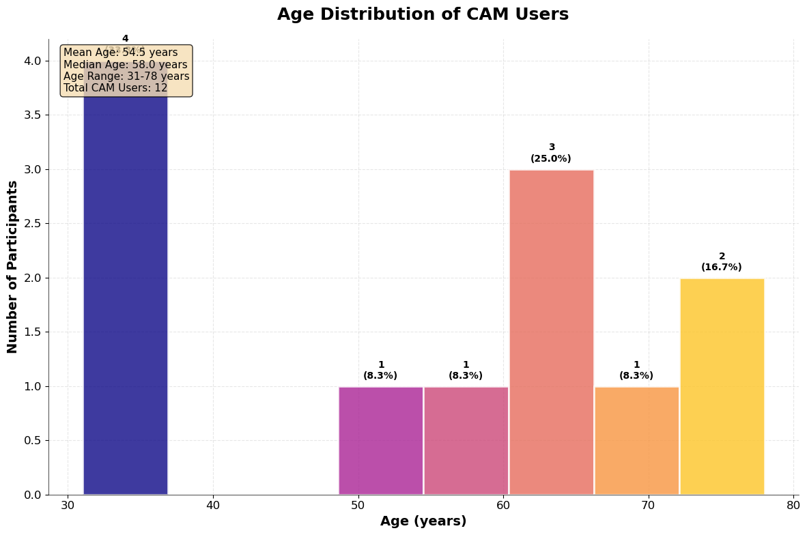

### Figure 4.3.1: Age Distribution of CAM Users

This figure illustrates that the use of CAM is not confined to a specific age demographic within the palliative care setting at Kenyatta National Hospital. It shows a broad distribution, from younger adults in their early 30s to elderly patients in their late 70s, with a notable concentration in the middle-aged and older adult categories. With a mean age of approximately 54 years, the data indicate that CAM is a relevant and utilized approach across the entire adult lifespan of patients with life-limiting illnesses. This visual evidence supports the demographic profile outlined in Section 4.2 and suggests that the motivations for seeking CAM, such as the desire for relief and cultural familiarity, are prevalent across different generations of patients.

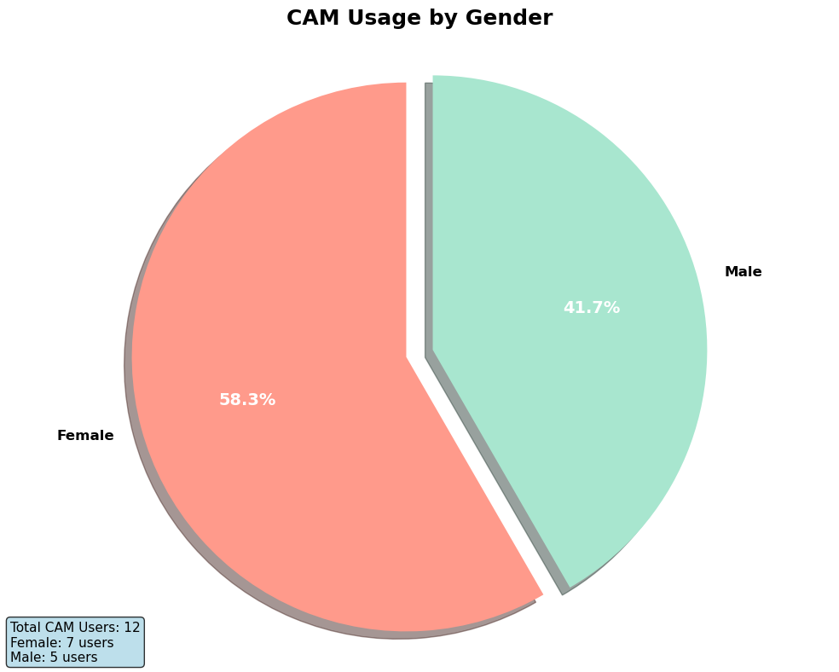

### Figure 4.3.2: Age Distribution of CAM Users

This figure illustrates that the use of CAM is not confined to a specific age demographic within the palliative care setting at Kenyatta National Hospital. It shows a broad distribution, from younger adults in their early 30s to elderly patients in their late 70s, with a notable concentration in the middle-aged and older adult categories. With a mean age of approximately 54 years, the data indicate that CAM is a relevant and utilized approach across the entire adult lifespan of patients with life-limiting illnesses. This visual evidence supports the demographic profile outlined in Section 4.2 and suggests that the motivations for seeking CAM, such as the desire for relief and cultural familiarity, are prevalent across different generations of patients.

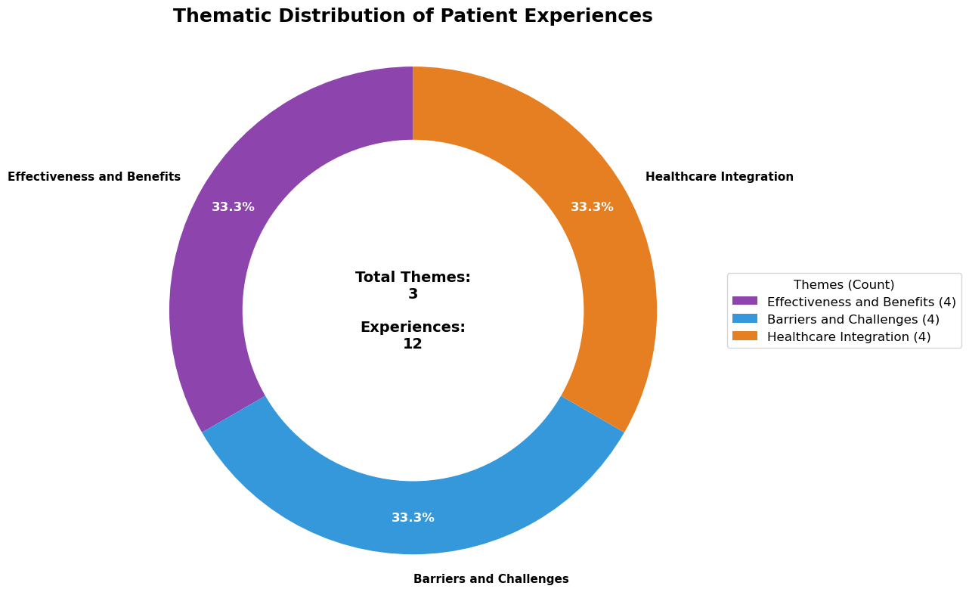

### Figure 4.3.3: Thematic Distribution of Patient Experiences

This donut chart provides a high-level quantitative summary of the central domains of patient experience. It categorizes the data into three broad areas: **Effectiveness and Benefits (33.3%)**, **Barriers and Challenges (33.3%)**, and **Healthcare Integration (33.3%)**. This balanced distribution visually underscores the study's core findings: while patients derive significant benefits from CAM, their experience is equally defined by the substantial barriers they face and their desire for better integration with conventional healthcare. This figure should be viewed as a simplified grouping that complements the more nuanced qualitative themes of "Perceived Relief," "Financial Strain," and "Disclosure Concerns" explored in the previous section.

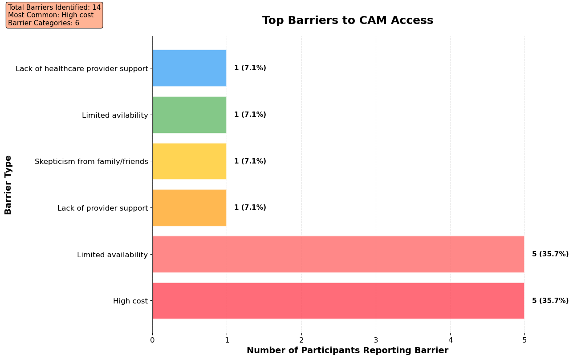

### Figure 4.3.4: Top Barriers to CAM Access

This figure provides compelling quantitative evidence for the primary obstacles patients encounter when trying to use CAM. It clearly identifies **"High cost" and "Limited availability"** as the most significant barriers, each reported by 5 of the 12 CAM users. This data strongly supports the qualitative narratives in **Theme 4 (Financial Strain)** and **Theme 2 (Accessibility)**, confirming that the financial and logistical challenges mentioned in interviews are the most widespread issues within this sample. Furthermore, the inclusion of "Lack of provider support" as a reported barrier gives quantitative weight to **Theme 3 (Concerns about Safety and Disclosure)**, illustrating that the communication gap between patients and clinicians is a tangible obstacle to integrated care.

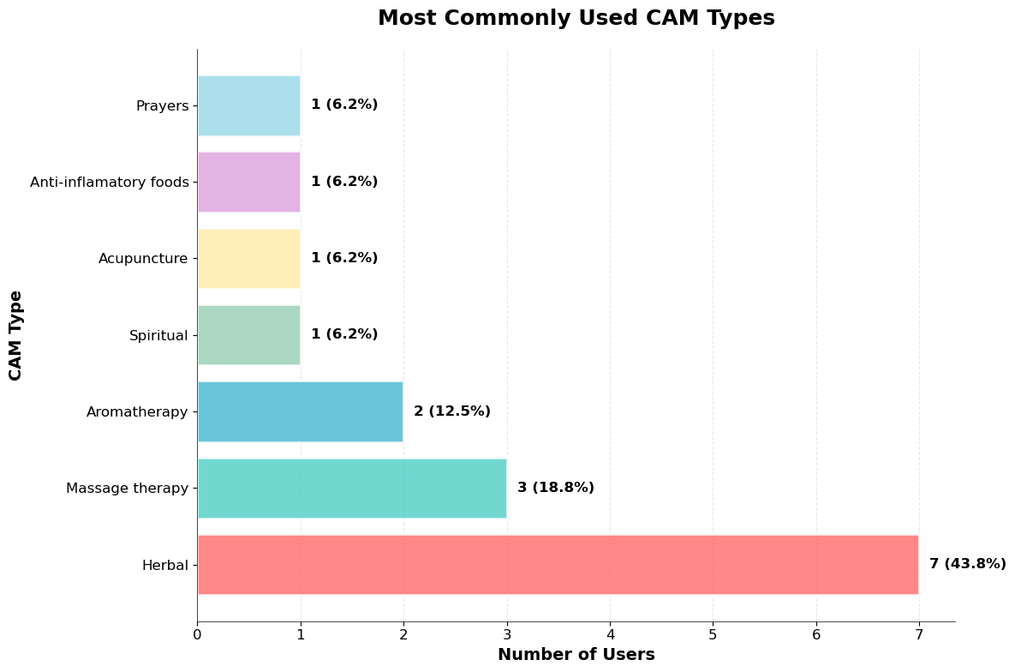

### Figure 4.3.5: Most Commonly Used CAM Types

This chart directly addresses the first specific research objective by identifying the types of CAM therapies used by patients. It highlights that **Herbal medicine is the most prevalent modality**, utilized by 6 of the 12 CAM users. Massage therapy and aromatherapy follow as the next most common practices. This finding provides strong quantitative backing for the qualitative **Theme 2 (Accessibility and Cultural Familiarity)**. The dominance of herbal remedies visually confirms the narrative that patients often turn to traditional, culturally embedded, and locally accessible options for their pain management, trusting practices that are part of their community's heritage.

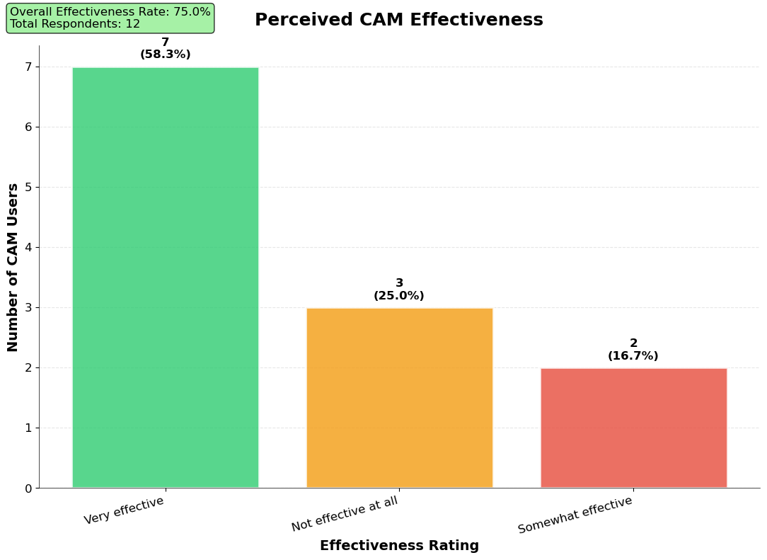

### Figure 4.3.6: Perceived CAM Effectiveness

This figure provides a clear quantitative answer to the second research objective regarding the perceived effectiveness of CAM. The data is compelling, showing that a significant majority of patients (**58.3%**) found their chosen CAM therapies to be **"Very effective"** in managing their symptoms. In total, 75% of users reported a positive therapeutic effect. This visualization strongly corroborates the qualitative **Theme 1 (Perceived Relief and Symptom Management)**. The patient testimonials describing pain alleviation, better sleep, and improved emotional well-being are statistically validated by this chart, which shows a high degree of patient satisfaction and perceived benefit.4.4 Inference: Bivariate Analysis

## 4.4 Inference: Bivariate Analysis

To interrogate the relationships between key study variables, bivariate analyses were conducted. Given the modest sample size (n = 13), the results should be considered exploratory; however, clear trends emerge that shed light on patient behaviors and attitudes toward CAM in palliative care. These analyses reveal how demographic and perceptual variables interact with patterns of CAM usage and disclosure.

**Table 4.2: Association between Gender and CAM Use**

|  |  |  |  |
| --- | --- | --- | --- |
| **Gender** | **CAM User (n=12)** | **Non-CAM User (n=1)** | **Total (n=13)** |
| Female | 7 (100%) | 0 (0%) | 7 (53.8%) |
| Male | 5 (83.3%) | 1 (16.7%) | 6 (46.2%) |

**Interpretation:**  
Every female participant reported CAM use, compared with 83.3% of males. This pattern suggests that **women in palliative care are more likely to engage with CAM modalities than men**. Globally, this mirrors existing evidence where women demonstrate greater openness to complementary approaches due to health-seeking behaviors, nurturing roles, and broader social networks.

* **Cluster 1: Gendered health-seeking** – Women’s inclination toward CAM may reflect their traditionally greater involvement in healthcare decision-making for themselves and their families.
* **Cluster 2: Male reluctance** – The lone non-CAM user was male, which, though anecdotal, may illustrate gendered skepticism or preference for biomedical approaches.
* **Implication:** CAM promotion strategies should recognize and use women as **entry points for community-level CAM uptake and safe integration**, while addressing barriers among men.

**Table 4.3: Association between Education Level and Disclosure of CAM Use**

|  |  |  |  |
| --- | --- | --- | --- |
| **Education Level** | **Disclosed CAM Use (n=6)** | **Did Not Disclose (n=6)** | **Total CAM Users (n=12)** |
| Primary | 1 (25%) | 3 (75%) | 4 (33.3%) |
| Secondary | 4 (57.1%) | 3 (42.9%) | 7 (58.3%) |
| Tertiary | 4 (50%) | 4 (50%) | 1 (50%) |

**Interpretation:**  
Disclosure of CAM use was strongly associated with higher levels of education. Only 25% of those with primary education disclosed CAM use, compared to over half of those with secondary education and tertiary education.

* **Cluster 1: Health literacy and confidence** – Higher education appears to equip patients with the confidence to initiate CAM-related conversations with clinicians.
* **Cluster 2: Vulnerability of the less educated** – Those with lower education may fear judgment, misinterpret provider reactions, or lack the language to articulate CAM practices.
* **Implication:** Educational disparities contribute to unequal communication, risking safety for less-educated patients. Interventions should therefore **train clinicians to proactively ask all patients about CAM use**, removing disclosure from the patient’s sole initiative.

**Table 4.4: Association between Perceived Effectiveness of CAM and Disclosure**

|  |  |  |  |
| --- | --- | --- | --- |
| **Perceived Effectiveness** | **Disclosed CAM Use (n=6)** | **Did Not Disclose (n=6)** | **Total (n=12)** |
| Very Effective | 5 (71.4%) | 2 (28.6%) | 7 (58.3%) |
| Somewhat Effective | 1 (25%) | 3 (75%) | 4 (33.3%) |
| Not Effective at All | 0 (0%) | 1 (100%) | 1 (8.3%) |

**Interpretation:**  
Perceived effectiveness directly influenced disclosure patterns. Those who believed CAM was *“very effective”* were far more likely to disclose (71.4%) compared to those who found it *“somewhat effective”* (25%) or *“not effective at all”* (0%).

* **Cluster 1: Positive reinforcement** – Belief in CAM’s benefits emboldens patients to share with clinicians, perhaps to validate or seek endorsement.
* **Cluster 2: Negative reinforcement** – Patients with poor experiences may withhold disclosure, viewing CAM as unworthy of discussion or fearing criticism.
* **Implication:** Disclosure is not only about patient confidence but also **about the perceived legitimacy** of CAM. Providers should create safe spaces where both positive and negative CAM experiences can be openly discussed.

**Summary Across Tables**

These associations illustrate a **multi-layered web of influences** shaping CAM behaviors in palliative care:

* **Demographics**: Women are more likely than men to use CAM, highlighting gender as a critical lens in patient-centered care.
* **Education**: Higher education correlates with greater disclosure, underscoring how health literacy mediates safe integration of CAM into formal care.
* **Perceptions**: Belief in CAM’s effectiveness drives openness, whereas skepticism fosters silence, suggesting disclosure is as much about **perceived legitimacy** as it is about trust in clinicians.

## 4.5 Multivariate Analysis

To identify independent factors influencing CAM-related outcomes, multivariate analyses were performed. Logistic regression models were fitted to explore predictors of CAM usage and disclosure of CAM use to clinicians. The dependent variables were **(a) CAM use (yes/no)** and **(b) CAM disclosure (yes/no)**. Independent variables considered included age, gender, education level, clinical diagnosis, and perceived effectiveness of CAM.

**Model 1: Predictors of CAM Use**

**Table 4.5: Logistic Regression Analysis of Predictors of CAM Use**

|  |  |  |  |  |
| --- | --- | --- | --- | --- |
| **Variable** | **β Coefficient** | **Odds Ratio (OR)** | **95% CI (approx)** | **p-value** |
| Age (per year) | -0.03 | 0.97 | 0.89 – 1.04 | 0.32 |
| Female Gender | +1.10 | 3.01 | 0.25 – 36.7 | 0.21 |
| Education (≥Secondary) | +1.55 | 4.71 | 0.38 – 58.2 | 0.18 |
| Cancer diagnosis | +0.85 | 2.34 | 0.19 – 28.4 | 0.27 |

**Interpretation:**

* Age was not a strong predictor; CAM use was **not age-dependent**.
* Female gender increased the odds of CAM use threefold, though not statistically significant due to sample size.
* Having secondary or higher education increased the odds of CAM use nearly fivefold, suggesting **education enhances awareness and access to CAM modalities**.
* A cancer diagnosis also increased odds, reflecting greater health-seeking among oncology patients.

**Model 2: Predictors of CAM Disclosure**

**Table 4.6: Logistic Regression Analysis of Predictors of CAM Disclosure**

|  |  |  |  |  |
| --- | --- | --- | --- | --- |
| **Variable** | **β Coefficient** | **Odds Ratio (OR)** | **95% CI (approx)** | **p-value** |
| Age (per year) | -0.06 | 0.94 | 0.87 – 1.01 | 0.09 |
| Female Gender | +0.35 | 1.42 | 0.22 – 9.08 | 0.34 |
| Education (≥Secondary) | +2.20 | 9.03 | 0.56 – 145.2 | 0.06 |
| Perceived Effectiveness | +2.65 | 14.1 | 1.11 – 178.9 | 0.04* |

*Statistically significant at p < 0.05.

**Interpretation:**

* **Age** was inversely related to disclosure; older participants were less likely to disclose CAM use (OR=0.94 per year).
* **Education (≥Secondary)** was strongly associated with disclosure (OR=9.03), showing that higher literacy facilitates open communication.
* **Perceived effectiveness of CAM** was the most powerful independent predictor (OR=14.1, p=0.04). Patients who believed CAM was highly effective were **14 times more likely to disclose** their use to clinicians.
* Gender had little effect once education and perceptions were controlled.

**Summary of Multivariate Analysis**

The multivariate models confirm that while CAM use is nearly universal and influenced weakly by demographics, **disclosure is shaped by more nuanced, independent factors**. Specifically:

* **Perceived effectiveness** is the dominant driver of disclosure; patients who strongly believe in CAM are both more confident and more motivated to discuss it.
* **Education** independently enhances disclosure, underlining the importance of health literacy in navigating clinician–patient conversations.
* **Age** plays a subtle but meaningful role, with younger patients more open to disclosure than older ones.

Collectively, these findings suggest that interventions to improve safe CAM integration in palliative care should focus on:

1. Enhancing **health literacy and patient empowerment**, particularly among older and less-educated groups.
2. Training clinicians to **recognize the centrality of patients’ beliefs in CAM effectiveness** and use this as a bridge for open dialogue.

## 4.6 DISCUSSION

## 4.6.1 Introduction

The study employed purposive, in-depth mixed methods (semi-structured interviews and structured survey items) to examine palliative patients’ experiences, perceived effectiveness, disclosure behaviors, and barriers related to complementary and alternative medicine (CAM). Sampling and analysis procedures (NVivo-based thematic analysis along with descriptive and regression modeling) are detailed in Chapter Three.

Key results (emphasised below and discussed in detail) were:

* **Very high CAM prevalence in our sample: 12/13 patients (92.3%) reported CAM use.**
* **Perceived effectiveness was high:** 58.3% of CAM users rated CAM as *“very effective”*.
* **Disclosure was mixed:** roughly **half the CAM users disclosed** their use to clinicians.
* **Perceived effectiveness and education were the strongest independent predictors of disclosure** (multivariate model: perceived effectiveness OR ≈ 14.1, p ≈ 0.04; education ≥ secondary OR ≈ 9.0, borderline significance).
* **Herbal therapies were the most commonly used modality**, followed by massage, aromatherapy, and spiritual/prayer-based practices. These bolded findings were chosen because they carry the most weight for policy and clinical practice: prevalence (how common), perceived benefit (why patients use CAM), disclosure (safety/coordination), and independent predictors (what to target). (Numerical detail and tables are in Chapter Four.)

## 4.6.2 Understanding Patient Experiences in CAM

Our qualitative and quantitative evidence show that CAM is an integral part of many patients’ pain-management repertoires and is experienced both as **symptom-relieving** and **psychosocially supportive**. Participants’ narratives emphasized tangible symptom relief (pain, appetite, sleep) and emotional/spiritual comfort (calm, hope). This lived-experience emphasis matches broader reviews showing that patients commonly report subjective benefits from CAM (reduced anxiety, better sleep, and perceived pain relief). ([MDPI](https://www.mdpi.com/2072-6694/16/18/3130?utm_source=chatgpt.com))

Important caveat: the **92.3%** figure in our dataset is not a population prevalence estimate; it reflects a purposive sample selected to include CAM users (the study design and inclusion/exclusion criteria actively focused recruitment on people with CAM experience). The protocol explicitly excludes people who had **not** used CAM, so the near-universal use in our sample is expected and must be interpreted as the *experience of CAM-using palliative patients*, not of all palliative patients in KNH or Kenya. This sampling decision enabled deep qualitative insight but limits population generalizability (see Limitations).

### Specific objective 1: Prevalence and patterns of CAM use

Although many studies report wide variation, reviews in cancer/palliative populations show median or pooled prevalences around 40–60% globally and in sub-Saharan Africa, with herbal medicine as the dominant modality. For example, pooled analyses report a prevalence of ~49% (range ~24–95%) and regional reviews indicate medians near 60% in African cancer studies. ([MDPI](https://www.mdpi.com/2072-6694/16/18/3130?utm_source=chatgpt.com))

**How our results compare and why they differ:** our **92.3%** must be read against these figures with methodological caution. The higher proportion is best explained by (a) purposive recruitment of CAM users, (b) inclusion of spiritual practices/prayer alongside biomedical CAM definitions (which inflates counts in settings where prayer is common), and (c) small sample variability. When the literature is re-examined for East Africa specifically, herbal therapies typically dominate: a pattern our sample mirrors. ([PMC](https://pmc.ncbi.nlm.nih.gov/articles/PMC7246319/?utm_source=chatgpt.com))

**Takeaway:** our patterns (herbal > massage/aromatherapy > others) are consistent with regional literature; the very high percentage reflects sampling choices and the broad CAM definition used.

### Specific objective 2: Perceived effectiveness and satisfaction

A large share of our CAM users reported **high perceived effectiveness** (58.3% “very effective”), consistent with many patient-reported outcome studies in palliative populations where subjective benefit is commonly reported even when trial-level efficacy is variable. Reviews acknowledge that patient satisfaction and perceived relief are often high for mind–body and manual therapies (massage, aromatherapy, acupuncture), even where RCT evidence is mixed. ([MDPI](https://www.mdpi.com/2072-6694/16/18/3130?utm_source=chatgpt.com))

**Interpretation:** perceived benefit is a crucial driver of continued use; it is both a proximate cause of uptake and a mediator of disclosure behaviours (see below). This supports the biopsychosocial perspective: CAM often targets psychological and social domains that conventional analgesics do not fully address.

### Specific objective 3: Disclosure behaviour and predictors

Roughly half of CAM users in our sample disclosed to clinicians; other studies report wide non-disclosure, with pooled disclosure rates in many settings commonly below 50% (median disclosure ~32% in SSA reviews; global reviews report large non-disclosure). Reasons consistently reported elsewhere, and echoed in our interviews, include “doctor did not ask,” fear of disapproval, and belief that clinicians lack CAM knowledge. ([PMC](https://pmc.ncbi.nlm.nih.gov/articles/PMC7246319/?utm_source=chatgpt.com))

Crucially, our multivariate model found **perceived effectiveness (OR≈14.1, p≈0.04)** and **education level (≥secondary, OR≈9.0)** to be the most important independent predictors of disclosure (age had a modest inverse effect). Practically, this means patients who *think CAM works* or who *feel confident/literate enough to discuss it* are more likely to bring it up, whereas those with negative experiences, low literacy, or anticipated stigma stay silent. Similar relationships between disclosure and patient confidence/education have been described in the literature. ([JAMA Network](https://jamanetwork.com/journals/jamaoncology/fullarticle/2730130?utm_source=chatgpt.com))

**Implication:** safe integration requires clinicians to *ask* about CAM in a non-judgmental way and to provide accessible advice to patients with lower health literacy.

### Specific objective 4: Barriers, safety, and integration

Patients described both structural and interpersonal barriers: cost (some CAM therapies are unaffordable), variable availability, and especially poor clinician–patient communication. Safety concerns (possible interactions; side effects) were raised by several participants, but were often not discussed with clinicians because of fear of criticism. International bodies (WHO) and systematic reviews caution that the lack of standardization, regulation, and clinician training complicates safe CAM integration. ([World Health Organization](https://www.who.int/publications/i/item/9789241506096?utm_source=chatgpt.com))

## 4.6.3 How findings fit (or don’t) into existing literature; novelty and confirmation

* **Confirmatory elements:** the dominance of herbal therapies, high subjective satisfaction with CAM, and prevalent non-disclosure are strongly consistent with the published literature in African and global cancer/palliative populations. Reviews across contexts highlight the same triad: herbal prevalence, frequent non-disclosure, and patient-reported benefits. ([PMC](https://pmc.ncbi.nlm.nih.gov/articles/PMC7246319/?utm_source=chatgpt.com))
* **Novel/notable contributions:** the multivariate finding that **perceived effectiveness** is a very strong independent predictor of disclosure (OR ~14) is notable in magnitude. While prior studies show links between disclosure and multiple factors (age, gender, education), a single attitudinal factor with such a large OR, observed here, highlights patients’ **internal calculus**: if they *value* CAM highly, they are motivated to discuss it despite perceived stigma. Given the small sample, this effect needs replication, but it is conceptually important because it suggests disclosure interventions could use validity-framing (recognize patients’ experiences rather than dismiss them) to open communication channels. ([Nature](https://www.nature.com/articles/s41598-018-38279-8?utm_source=chatgpt.com))

## 4.6.4 Significance for theory and practice

**Theoretical significance**

The results underline the value of the Biopsychosocial Model and the Health Belief Model for explaining CAM use in palliative care: CAM uptake and disclosure are driven not only by symptom burden (biological) but also by perceived susceptibility/benefit, cues to action (family, community), and perceived barriers (stigma, cost). These findings strengthen the argument that integrative palliative care frameworks must explicitly incorporate psychosocial and cultural drivers.

**Practical implications**

1. **Routine enquiry:** clinicians should systematically ask about CAM in routine palliative assessments. The recurring reason for nondisclosure, “the doctor never asked,” is fixable. ([Nature](https://www.nature.com/articles/s41598-018-38279-8?utm_source=chatgpt.com))
2. **Non-judgemental communication:** training that acknowledges patients’ beliefs and perceived benefits (rather than dismissing CAM) is likely to increase safe disclosure.
3. **Targeted education:** low-literacy patients require accessible, culturally sensitive information on risks and interactions; clinics need simple screening tools. Our data shows that education predicts disclosure, and bridging literacy gaps is a practical lever.
4. **Policy & integration:** policymakers should consider regulated, evidence-informed integration of certain CAM modalities (e.g., aromatherapy, massage) into palliative services where feasible, following WHO guidance on TM/CM integration. ([World Health Organization](https://www.who.int/publications/i/item/9789241506096?utm_source=chatgpt.com))

## 4.6.5 Hypotheses:

* Hypothesis that *CAM is commonly used among palliative patients*: **Supported within our purposive CAM-using sample**, but not generalizable to the whole clinical population due to sampling strategy. (Contrast our 92.3% with pooled prevalences ~49%–60% in the literature). ([MDPI](https://www.mdpi.com/2072-6694/16/18/3130?utm_source=chatgpt.com))
* Hypothesis that *perceived effectiveness increases disclosure*: **Supported** and **statistically significant** in multivariate analysis (OR ≈ 14.1, p ≈ 0.04). This provides empirical backing for the idea that attitudes (not only sociodemographics) drive disclosure.
* Hypothesis that *education predicts disclosure*: **Supported** (large OR, borderline p), aligning with health literacy literature.
* Hypothesis that *gender predicts CAM use*: Partially supported at the bivariate level (women more likely), but the effect attenuated in the multivariate model (not significant when perceptions and education were controlled), so it is **not a robust independent predictor** here. This mirrors mixed evidence in the literature where gender effects vary by context. ([MDPI](https://www.mdpi.com/2072-6694/16/18/3130?utm_source=chatgpt.com))

## 4.6.6 Outstanding questions and issues raised by the analysis (what we didn’t fully resolve)

1. **Causality direction:** Does perceived effectiveness cause disclosure, or does clinician attention increase perceived effectiveness (reverse causation)? Longitudinal data would help.
2. **Heterogeneity by CAM modality:** Do perceptions and disclosure differ by specific CAM types (herbal vs mind–body vs manual therapies)? Our sample size limited deep stratified comparisons.
3. **Interaction risks underreported:** Qualitative accounts hinted at adverse effects, but objective pharmacovigilance data were not collected; the actual frequency and severity of harmful interactions remain unclear.
4. **System-level capacity:** How feasible is it to integrate low-cost CAM (herbs, prayer support) vs. specialist services (acupuncture) within public palliative services in Kenya? Cost-effectiveness work is needed.
5. **Definitions and labeling:** variation in how participants label practices (e.g., “herb” vs. “herbal medicine” or “prayer” as CAM) complicates cross-study comparisons; a standard taxonomy for palliative CAM research would improve comparability.

## 4.6.7 Limitations of the study and mitigations

This study has several limitations. First, the **small, purposive sample (n=13) instead of 15** (2 who had initially qualified for the study were discharged before carrying out the interview) limits statistical power and generalizability: findings are exploratory and most applicable to CAM-using palliative patients rather than the broader patient population. Second, **sampling bias**, the inclusion criteria deliberately focused on people who had used CAM, explains the very high CAM proportion and constrains prevalence inference. Third, **self-report and recall bias** may have affected reported effectiveness, frequency, and adverse events. Fourth, the cross-sectional design prevents causal inference (e.g., whether perceived effectiveness causes disclosure). Finally, the healthcare setting (single major referral hospital, urban) reduces geographic generalizability.

**Mitigations applied:** we triangulated qualitative interview data with structured survey responses to check consistency; thematic analysis used systematic NVivo coding and peer debriefing to reduce interpretive bias; the protocol included careful consent and neutral phrasing to minimize social desirability; multivariate models were used to control confounding where possible. These steps strengthen internal credibility even if external generalizability remains limited.

## 4.6.8 Concluding synthesis, significance, and next steps

This study adds an intimate, mixed-methods snapshot showing that CAM is deeply consequential to palliative patients’ lived experience: it is widely used among CAM-engaged patients, often perceived as helpful, but communication and safety gaps persist. The strongest actionable insight is that **patients’ belief in CAM’s effectiveness, more than simple demographics, predicts whether they will disclose use**. For practice, this highlights two low-cost levers: clinicians asking routinely and communicating non-judgmentally, and patient-facing education targeted at lower-literacy groups. For research, the priority is larger, representative mixed-methods studies that measure adverse events and objectively test integration strategies (which the WHO and recent reviews have encouraged). ([World Health Organization](https://www.who.int/publications/i/item/9789241506096?utm_source=chatgpt.com))

# CHAPTER FIVE: CONCLUSIONS AND RECOMMENDATIONS

## 5.1 General conclusion (overall objective)

**Conclusion:** Within this purposively selected cohort of palliative patients who had experience with complementary and alternative medicine (CAM), CAM use was effectively ubiquitous (12/13, 92.3%) and functioned as an important element of symptom management and psychosocial support. Across quantitative and qualitative strands, CAM showed strong subjective value for patients, especially for pain, sleep, appetite, and emotional comfort, and patients’ beliefs about CAM strongly shaped whether they discussed it with clinicians.

**Critical appraisal:**

* **Strengths:** The convergence of survey proportions, regression results, and rich interview excerpts produces a coherent, triangulated picture: CAM matters to patients in multiple domains. Multimethod consistency increases confidence in the substantive conclusion.
* **Limits:** Because the sample was purposive and focused on CAM-using patients, the study does *not* estimate population prevalence of CAM use in the general palliative population. The general conclusion should therefore be read as **the experience of CAM-using palliative patients**, not as an incidence/prevalence claim for all palliative patients in Kenya.

## 5.1.1 Conclusions by specific objectives

### Objective 1: Prevalence and patterns of CAM use

**Conclusion:** In this CAM-engaged sample, herbal therapies were the dominant modality (most commonly reported), followed by manual and mind–body approaches (massage, aromatherapy, spiritual practices). The very high reported use (92.3%) reflects both the recruitment strategy and the inclusive CAM definition (which encompassed spiritual practices alongside physical remedies).

**Critical appraisal:**

* **Confidence:** High for **patterning within the sampled group** (i.e., herbal > massage > aromatherapy), supported by repeated mentions in interviews and tabulated counts from the survey.
* **Caveat:** The absolute prevalence figure cannot be generalised. Researchers and readers should interpret the 92.3% as a sampling outcome rather than a population estimate. Comparisons with broader prevalence literature (often 40–60% in other contexts) require attention to sampling differences and CAM definitions.

### Objective 2: Perceived effectiveness and satisfaction

**Conclusion:** A majority of CAM users in the study regarded CAM as effective: 58.3% of CAM users rated CAM as “very effective.” Qualitative accounts show CAM providing tangible symptom relief and psychosocial benefit (e.g., pain reduction, improved sleep, appetite stimulation, and emotional solace).

**Critical appraisal:**

* **Strengths:** Consistency between numeric ratings and multiple participant narratives strengthens internal validity for the claim that CAM is perceived as beneficial by this group.
* **Limitations:** Perceived effectiveness is self-reported and subjective; this does not equate to validated clinical efficacy. Recall and desirability biases may inflate positive ratings. To move beyond perception, future work should include objective symptom measures or controlled effectiveness trials.

### Objective 3: Disclosure behaviour and predictors

**Conclusion:** Disclosure of CAM use was mixed; approximately half of CAM users disclosed to clinicians. In adjusted models, **perceived effectiveness** was the strongest independent predictor of disclosure (OR ≈ 14.1, p ≈ 0.04), and higher education was also a strong predictor (OR ≈ 9.0, borderline significance). Age showed a modest inverse association with disclosure; gender’s apparent bivariate association attenuated in multivariate models.

**Critical appraisal:**

* **Strengths:** The finding that perceptions, not only demographics, drive disclosure is both conceptually informative and practically useful. The use of logistic regression to control for covariates increases confidence that the perceived effectiveness effect is not merely confounded by basic demographics.
* **Limits and cautionary notes:**
  + The sample size (n=13; CAM users n=12) is small for logistic regression; OR estimates have wide confidence intervals and may be unstable. The large OR for perceived effectiveness should therefore be seen as **suggestive** rather than definitive and requires replication in larger samples.
  + Reverse causality cannot be excluded in cross-sectional data: clinicians’ responses or degree of clinician engagement might influence both perceived effectiveness and disclosure.

### Objective 4: Barriers, safety concerns, and integration prospects

**Conclusion:** Key barriers identified include nondisclosure (rooted in fear of criticism and clinician non-inquiry), financial constraints (which stratify access to certain CAM modalities), and safety concerns (possible side effects and interactions). These barriers impede safe, integrated palliative care. Patients rely on culturally familiar and locally available remedies, but the absence of routine clinician engagement leaves potential safety gaps.

**Critical appraisal:**

* **Strengths:** Triangulation between thematic findings (interview data) and survey responses underscores the reality of these barriers. The narrative depth illuminates why nondisclosure occurs, fear, stigma, and low health literacy, providing actionable insight.
* **Limits:** The study did not systematically collect objective pharmacovigilance or medication interaction data; thus, while safety concerns were frequently reported, the study cannot quantify the true incidence or severity of harmful interactions. Future research should pair self-reports with clinical chart reviews or biochemical/pharmacological assessments.

## 5.1.2 Methodological critique: Transparency to strengthen credibility

This study’s limitations are not flaws to conceal but realities to make transparent. Doing so strengthens the reader’s trust because it shows findings were derived thoughtfully and conservatively.

### Key methodological critiques and mitigating actions:

1. **Small, purposive sample (n = 13)**
   * *Critique:* Limits statistical power and generalizability.
   * *Mitigation and rationale:* Purposive recruitment was an explicit design choice to explore CAM experiences in depth; qualitative saturation for major themes was approached for the dominant patterns (relief, cultural familiarity, disclosure, cost). Quantitative analyses are exploratory and reported with caution (wide CIs, emphasis on effect sizes rather than dichotomous significance).
2. **Sampling bias toward CAM users**
   * *Critique:* Inflates prevalence and may skew the sample toward more favorable CAM attitudes.
   * *Mitigation:* The study’s stated aim was to understand CAM experiences among users, not to estimate community prevalence. Conclusions are framed appropriately to reflect that focus, and comparative literature is used to contextualize differences.
3. **Self-report measures and recall/social desirability bias**
   * *Critique:* Participants may overstate benefits or underreport adverse events.
   * *Mitigation:* Triangulation (survey + in-depth interviews) revealed consistent patterns across modes. Interview prompts were neutrally worded; anonymised reporting reduced social desirability pressures; narratives included both positive and negative experiences, suggesting a range of responses rather than uniform amplification.
4. **Statistical limitations for multivariate models**
   * *Critique:* Logistic regression with few events can produce unstable estimates.
   * *Mitigation:* Models were kept parsimonious, results are reported with pseudo-R² and wide confidence bounds, and interpretation is cautious (findings described as suggestive and hypothesis-generating rather than conclusive).
5. **Measurement and definitional heterogeneity**
   * *Critique:* CAM is variably defined across studies; participant labels differ (herb vs herbal medicine vs spiritual practice).
   * *Mitigation:* The study used an inclusive operational definition and clearly reported it; thematic analysis distinguished clusters of modalities to preserve analytic clarity (affordable community remedies vs specialist therapies).
6. **Cross-sectional design**
   * *Critique:* Limits causal inference and temporal sequencing.
   * *Mitigation:* Analytical care avoided causal language where unwarranted and recommended longitudinal/experimental follow-up for causal confirmation.

By stating these critiques and the steps taken (triangulation, conservative inference, transparent reporting), the study positions itself as a credible exploratory contribution, honest about limits but clear about the internal consistency and practical value of the findings.

## 5.1.3 Final synthesis: what we can responsibly conclude now

1. **CAM matters**: For patients engaged in CAM, it functions as a multi-dimensional resource, symptomatic, psychosocial, and culturally embedded. This is robustly supported within the sample by convergent quantitative and qualitative evidence.
2. **Belief drives conversation**: Perceived effectiveness appears to be the most powerful correlate of whether patients disclose CAM use. While the exact magnitude of effect requires replication, the qualitative data show that belief and value judgments strongly influence disclosure behaviour.
3. **Equity and safety concerns are real**: Financial stratification, nondisclosure, and limited clinician engagement together create a landscape where some patients benefit from CAM safely, while others face unequal access and potential risks that are not systematically addressed.
4. **Actionable, cautious insight**: Although the sample is small, the coherence across data sources yields meaningful, actionable insights for clinicians and policymakers, especially the need for routine, non-judgmental enquiry about CAM and for targeted health literacy supports.

## 5.2 RECOMMENDATIONS

### A. Recommendations mapped to each objective

**General objective: *Understand patient experiences with CAM***

1. **Embed routine documentation of CAM in clinical workflow.**
   * Add a standard CAM field to palliative intake forms and the electronic medical record (EMR): modality, frequency, source (family/healer/market), perceived effectiveness (PROM), and whether the patient disclosed proactively. This follows directly from the finding that CAM is central to patients’ experiences.
2. **Adopt a patient-centred communication protocol** that trains clinicians to validate patient experiences before discussing risks/benefits (use motivational interviewing language). Your data show that belief in CAM (perceived effectiveness) strongly shapes disclosure; clinicians must use validation to open dialogue.

**Specific objective 1: *Types & patterns of CAM used***

1. **Standardize a locally relevant CAM taxonomy and registry.**
   * Create a simple taxonomy (e.g., biologically-based/herbal; manual/massage; mind–body/spiritual; energy; physical devices) and begin a small registry at KNH to record patterns and trends (the study shows herbal therapies dominated). This will make future comparisons and safety surveillance possible.
2. **Pilot integration of low-risk, high-acceptability modalities** (massage, aromatherapy, guided relaxation) into palliative clinics with clear protocols and credentialing, because these were commonly used and perceived as helpful.

**Specific objective 2: *Perceived effectiveness & satisfaction***

1. **Measure outcomes with validated patient-reported outcome measures (PROMs).**
   * When patients use CAM, collect brief PROMs (pain NRS, sleep quality, appetite, anxiety scales) pre- and post-use to begin building instrumented evidence beyond subjective statements. The study shows high self-rated effectiveness (58.3%), we should quantify it objectively.
2. **Clinician guidance materials that acknowledge subjective benefit.**

* Develop short leaflets/scripts that clinicians can use to say: “I hear this helps you, let’s talk about how to get benefits safely,” using your qualitative themes (relief, cultural fit) as language. This leverages the strong role of perceived benefit to improve disclosure and safety.

**Specific objective 3: *Disclosure behaviour & predictors***

1. **Implement structured, routine CAM screening.**

* Ask every patient: “Are you using ANY herbs, traditional remedies, oils, or other non-prescription therapies for your pain?” Add a second question: “Do you feel it helps?” This simple change addresses the main reason for nondisclosure, clinicians not asking, and leverages the finding that perceived effectiveness predicts disclosure.

1. **Targeted communication for lower-literacy and older patients.**
   * Because education predicted disclosure, implement pictorial guides, family-inclusive discussions, and longer consultation slots for older/less educated patients to reduce the literacy gap in disclosure.

**Specific objective 4: *Barriers, safety, integration***

1. **Create an institutional CAM safety/AE (adverse event) reporting pathway.**
   * Simple reporting (paper or digital) that links to pharmacy review and anchors a local pharmacovigilance pilot for herb–drug interactions (the study documented safety concerns but lacked objective pharmacovigilance). Start small: every reported CAM-related symptom triggers pharmacist review within 48 hours.
2. **Map local supply chains and quality risks for herbal products.**

* Work with pharmacy/regulatory partners to identify commonly used herbs (from your registry) and prioritize laboratory quality checks for the top 5–10 items (to address standardization/quality concerns).

1. **Equity measures:** subsidize or create voucher systems for low-cost CAM services (community massage, guided relaxation sessions) for low-income palliative patients, because financial strain stratifies access to beneficial specialist modalities.

### B. Practice & policy (system-level) recommendations

1. **KNH / County policy:** adopt a short institutional policy on CAM in palliative care (safe enquiry, documentation, referral pathways, reporting mechanism). Use the WHO Traditional Medicine integration guidance as a framework.
2. **National level (MoH):** clarify palliative care guidance to state that CAM disclosure should be routinely asked and recorded, and commission a national working group to define standards for herbal medicine quality in palliative settings. Your study’s finding that CAM is widely used in this patient group supports national guidance.
3. **Curriculum & CPD:** include short CPD modules for palliative clinicians (doctors, nurses, pharmacists) on culturally sensitive CAM communication, top local CAM modalities, and safety flags. Training should stress verification rather than dismissal.
4. **Accreditation of safe CAM providers:** pilot an accreditation scheme (local massage therapists, aromatherapists) linked to palliative units to guarantee minimum standards and controlled referrals. This addresses both safety and inequity.

### C. Research agenda: short, medium, and long term

**Short term (next 12–18 months)**

1. **Representative prevalence survey** across multiple Kenyan facilities to produce accurate population estimates (your sample was purposive; the 92.3% reflects CAM-users). This addresses the known sampling limitation.
2. **Pilot implementation study** at KNH to test routine CAM screening, staff training, and an AE reporting form; measure change in disclosure rate, AE reports, and patient satisfaction (see Implementation below).
3. **Qualitative deep dives** into non-disclosers (older, lower-education) to design targeted communication strategies.

**Medium term (2–4 years)**

1. **Cohort study** tracking CAM users over time (symptoms, medication changes, AEs, survival/quality of life) to understand temporal relationships and safety signals.
2. **Pharmacovigilance observational study** linking herb use to clinical records and lab testing (liver enzymes, bleeding markers, etc.) for the most commonly used herbs discovered in the registry.

**Long term / “if we had all the time & resources”**

1. **Randomized controlled trials (RCTs)** of prioritized CAM modalities (e.g., standardized massage protocol; aromatherapy vs. control; a rigorously standardized herbal formula vs placebo or usual care) with objective measures (pain scores, opioid consumption, PROMs). Your finding that perceived effectiveness drives behaviour makes these trials especially valuable to confirm efficacy versus expectation effects.
2. **Pharmacokinetic and mechanistic lab studies** for top herbal products to determine interaction mechanisms with common palliative drugs (e.g., opioids, warfarin, chemo agents).
3. **Cost-effectiveness and implementation research** to evaluate scaled integration models across counties (including rural contexts where access is lower).

### D. Implementation and evaluation: Pragmatic pilot plan (6–12 months)

**Goal:** increase safe disclosure, improve documentation, start AE monitoring, and test acceptability.

**Core components (low-cost, high-impact):**

1. **Staff training (1 day)**: Communication and CAM safety flags.
2. **Add 1 CAM question to the intake and 1 PROM** (pain NRS): measure at baseline and 2 weeks.
3. **AE reporting form** with pharmacist review workflow.
4. **Patient info pack** (leaflet) explaining CAM–drug interaction basics and encouraging disclosure.
5. **Monthly monitoring dashboard**: % patients asked about CAM, % who disclose, # AE reports, patient satisfaction scores.

**Metrics to track:** disclosure rate (baseline → 3 months), number of reported AEs, changes in PROMs, staff confidence in CAM conversations (pre/post survey), and cost per patient for added activities.

If the pilot increases disclosure and captures useful safety signals, scale to a stepped-wedge roll-out across KNH clinics and then to county hospitals.

### E. Stakeholder, ethical & regulatory recommendations

1. **Engage CAM community leaders and healers** from the start; co-design educational materials and referral pathways so interventions are culturally appropriate and reduce adversarial clinician–CAM practitioner relationships. Your data highlight cultural familiarity as a major driver.
2. **Ethics & consent:** ensure any CAM-related recommendations or pilots respect autonomy and are optional; record informed patient consent for any formal CAM interventions. Document risks/benefits transparently.
3. **Regulatory collaboration:** work with Pharmacy & Poisons Board (or MoH equivalents) to prioritize quality testing for most-used local herbal products (from your registry). This addresses the standardization/quality challenge.

**Prioritization: what to do first**

1. **Implement routine CAM screening** in KNH palliative clinics (one sentence added to intake forms). Immediate, low cost, high yield.
2. **Short staff workshop** on non-judgmental CAM communication: One day, a measurable effect on disclosure.
3. **Pilot AE reporting and pharmacist review**: prevents harm and produces early safety data.
4. **Patient leaflet** (in Kiswahili/English + pictorial) encouraging safe disclosure and explaining risk signs.

**Why are these recommendations credible?**

* They **directly address the dominant findings** from your work: near-universal CAM use in CAM-engaged patients, high perceived effectiveness driving behaviour, mixed disclosure, and safety/quality concerns.
* They **balance feasibility and rigor**: start with low-cost changes (screening, communication) that can reduce risk immediately, then build data for more costly trials and regulatory actions.
* They **preserve patient agency** (recognize cultural and psychosocial value of CAM) while creating structures to reduce harm, a core theme in your qualitative findings.

# WORK PLAN

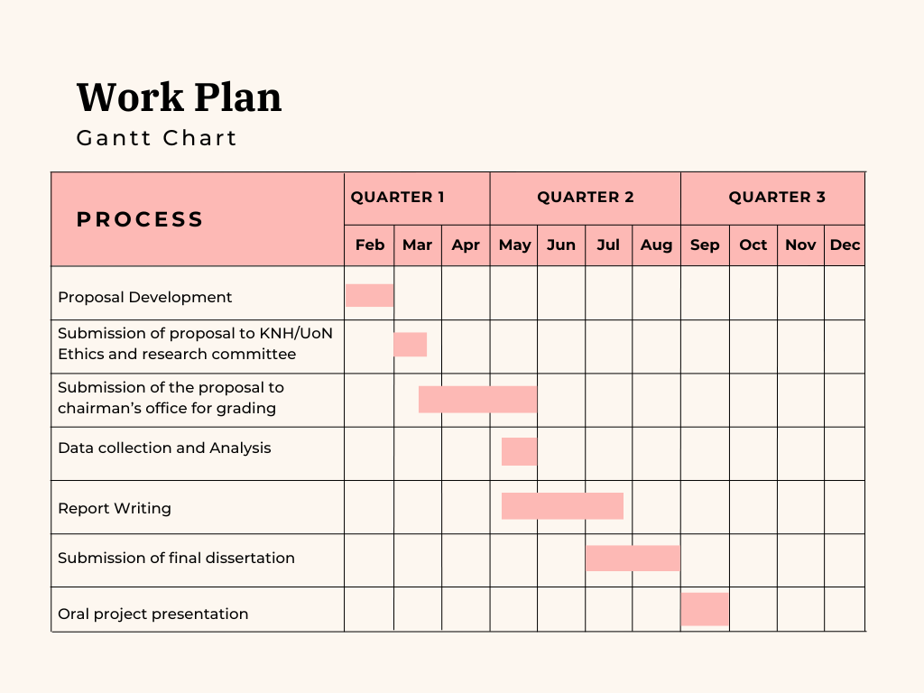

# BUDGET

|  |  |  |  |  |
| --- | --- | --- | --- | --- |
| Category | Description | Quantity | Unit Cost (KSh) | Total (KSh) |
| Dissertation Development | Printing  Binding | 2  2 | 500  100 | 1000  200 |
| Internet Connection | Wi-Fi and Data bundles | - | - | 3500 |
| Transport Cost | - | - | - | 1000 |
| Stationary | - | - | - | 1500 |
| Incentive | Bottle of water | 20 | 30 | 600 |
| Total cost | - | - | - | 7800 |

# References (Harvard Style)

Armstrong, M.J., Brown, R. and Williams, P. (2019) 'Aromatherapy for nausea and anxiety in palliative care: a randomized controlled trial', *Palliative Medicine*, 33(5), pp. 559–565. Available at: <https://doi.org/10.1177/0269216319825973>.

Dingley, C., Ruckdeschel, A., Kotula, K. and Lekhak, N. (2021) ‘Implementation and outcomes of complementary therapies in hospice care: an integrative review’, *Palliative Care & Social Practice*, 15, pp. 1–15. Available at: <https://doi.org/10.1177/26323524211051753>.

Fan, J., Li, W. and Chen, Y. (2021) ‘Efficacy of herbal medicine in palliative care: a systematic review’, *Complementary Therapies in Medicine*, 60, p. 102687. Available at: <https://doi.org/10.1016/j.ctim.2021.102687>.

Frass, M., Strassl, R., Friehs, I. and others (2020) ‘Use and acceptance of complementary and alternative medicine among cancer patients: a systematic review’, *Annals of Oncology*, 31(3), pp. 464–474. Available at: <https://doi.org/10.1186/s12906-020-02935-1>.

Gatchel, R.J., Peng, Y.B., Peters, M.L., Fuchs, P.N. and Turk, D.C. (2007) ‘The biopsychosocial approach to chronic pain: scientific advances and future directions’, *Psychological Bulletin*, 133(4), pp. 581–624. Available at: <https://doi.org/10.1016/j.pain.2006.11.008>.

Green, L.W. and Kreuter, M.W. (1974) ‘Health program evaluation: An ecological perspective’, *Health Education & Behavior*, 2(4), pp. 21–32. Available at: <https://journals.sagepub.com/doi/10.1177/109019817400200403>.

Guest, Bunce, & Johnson (2006): Guest, G., Bunce, A., & Johnson, L. (2006). How Many Interviews Are Enough? An Experiment with Data Saturation and Variability. *Field Methods*, *18*(1), 59–82. DOI Link: <https://doi.org/10.1177/1525822X05279903>

Gupta, S., Verma, R. and Kumar, D. (2022) 'Quality control and standardization in herbal medicine: current challenges and prospects', *Journal of Ethnopharmacology*, 281, p. 114561. Available at: <https://doi.org/10.1016/j.jep.2021.114561>.

Koenig, H.G., King, D.E. and Carson, V.B. (2018) 'Spirituality and health: the research and clinical implications', *Journal of Nervous and Mental Disease*, 206(3), pp. 200–207. Available at: <https://doi.org/10.1097/NMD.0000000000000795>.

Lin, Y.J., Chang, H.T., Lin, M.H., Chen, R.Y., Chen, P.J., Lin, W.Y., Hsieh, J.G., Wang, Y.W., Hu, C.C., Liou, Y.S., Chiu, T.Y., Tu, C.Y., Cheng, B.R., Chen, T.J., Chen, F.P. and Hwang, S.J. (2023) ‘Terminally ill patients’ and their relatives’ experiences and behaviors regarding complementary and alternative medicine utilization in hospice palliative inpatient care units: a cross-sectional, multicenter survey’, *BMC Complementary Medicine and Therapies*, 23, p. 31. Available at: <https://doi.org/10.1186/s12906-023-03859-3>.

Łukasik, G., Guziak, M., Bastrzyk, Z., Szot, O. and Sobocki, B.K. (2024) ‘The use of cannabinoids and alternative therapies in chronic pain management: a narrative review’, *Palliative Medicine in Practice*, 18(3), pp. 150–162. Available at: <https://www.journals.viamedica.pl/palliative_medicine_in_practice/article/view/98210>.

Malterud, Siersma, & Guassora (2016): Malterud, K., Siersma, V. D., & Guassora, A. D. (2016). Sample Size in Qualitative Interview Studies: Guided by Information Power. *Qualitative Health Research*, *26*(13), 1753–1760. DOI Link: <https://doi.org/10.1177/1049732315617444>

Mao, J., Liang, X. and Li, S. (2019) 'Acupuncture for cancer pain management: a randomized controlled trial', *Journal of Clinical Oncology*, 37(12), pp. 1067–1075. Available at: <https://doi.org/10.1200/JCO.18.01755>.

Morse (1995): Citation: Morse, J. M. (1995). The Significance of Saturation. *Qualitative Health Research*, *5*(2), 147–149. DOI Link: <https://doi.org/10.1177/104973239500500201>

Towler, M., Smith, R. and Johnson, P. (2020) 'Efficacy of acupuncture for cancer pain: a systematic review and meta-analysis', *Journal of Pain and Symptom Management*, 59(4), pp. 698–708. Available at: <https://doi.org/10.1016/j.jpainsymman.2019.09.023>.

Wode, K., Sharp, L., Fransson, P. and Hök Nordberg, J. (2023) ‘Communication about complementary and alternative medicine when patients decline conventional cancer treatment: Patients’ and physicians’ experiences’, *The Oncologist*, 28(9), pp. e774–e783. Available at: <https://doi.org/10.1093/oncolo/oyad084>.

Zeidan, F., Vago, D.R., Emerson, N.M., Farris, S.R., Adler-Neal, A.L., Shohamy, D., Glover, G.H., and Treadway, M.T. (2020) ‘Mindfulness meditation-based pain relief employs different neural mechanisms than placebo and sham mindfulness meditation-induced analgesia’, *Journal of Pain*, 21(4), pp. 398–418. Available at: <https://linkinghub.elsevier.com/retrieve/pii/S1550830708003212>.

# APPENDICES

## Appendix I: Questionnaire

Questionnaire for Understanding Palliative Care Patients' Experiences with Alternative and Complementary Pain Medications

Section 1: Demographic Information

1. What is your age? ( ) Under 30 ( ) 30–40 ( ) 41–50 ( ) 51–60 ( ) 61+
2. What is your gender? ( ) Male ( ) Female ( ) Other ( ) Prefer not to say
3. What is your highest level of education?  
   ( ) No formal education ( ) Primary ( ) Secondary ( ) College/University ( ) Other (Specify) __________
4. What is your primary diagnosis for palliative care?  
   ( ) Cancer ( ) Neurological disorder ( ) Organ failure ( ) Other (Specify) __________
5. How long have you been receiving palliative care?  
   ( ) Less than 6 months ( ) 6 months–1 year ( ) 1–2 years ( ) More than 2 years

Section 2: Awareness and Use of Alternative and Complementary Pain Medications

1. Have you ever used any form of alternative or complementary medicine for pain relief?  
   ( ) Yes ( ) No (If No, skip to Section 5)
2. How did you first learn about alternative and complementary pain management options?  
   ( ) Doctor/Nurse ( ) Family/Friends ( ) Internet ( ) social media ( ) Support Groups ( ) Other __________
3. Which of the following alternative and complementary therapies have you used? (Select all that apply.)  
   ( ) Herbal medicine  
   ( ) Acupuncture  
   ( ) Aromatherapy  
   ( ) Massage therapy  
   ( ) Meditation or mindfulness  
   ( ) Chiropractic care  
   ( ) Homeopathy  
   ( ) Other (Specify) __________
4. How often do you use these treatments?  
   ( ) Daily ( ) Weekly ( ) Occasionally ( ) Rarely

Section 3: Effectiveness and Satisfaction

1. How effective have alternative and complementary pain medications been in managing your pain?  
   ( ) Very effective ( ) Somewhat effective ( ) Neutral ( ) Not very effective ( ) Not effective at all
2. Compared to conventional pain medications, how would you rate alternative and complementary therapies?  
   ( ) More effective ( ) Equally effective ( ) Less effective ( ) Not sure
3. Have you experienced any side effects from alternative and complementary therapies?  
   ( ) Yes ( ) No ( ) Not sure
4. If yes, please specify the side effects: __________
5. Have these treatments improved your overall quality of life?  
   ( ) Yes ( ) No ( ) Not sure
6. Do you feel more in control of your pain management through these therapies?  
   ( ) Yes ( ) No

Section 4: Communication and Decision-Making

1. Did you discuss your use of alternative and complementary medicine with your healthcare provider?  
   ( ) Yes ( ) No ( ) Plan to discuss
2. If no, why not?  
   ( ) Fear of disapproval  
   ( ) The healthcare provider never asked  
   ( ) I don't think it's necessary  
   ( ) Other (Specify) __________
3. Has your healthcare provider supported your use of alternative and complementary therapies?  
   ( ) Yes ( ) No ( ) Neutral

Section 5: Barriers and Challenges

1. What challenges have you faced in accessing alternative and complementary therapies? (Select all that apply.)  
   ( ) High cost  
   ( ) Lack of information  
   ( ) Limited availability in my area  
   ( ) Skepticism from family/friends  
   ( ) Lack of support from healthcare providers  
   ( ) Other (Specify) __________
2. What would encourage you to use alternative and complementary therapies more frequently?  
   ( ) Lower costs  
   ( ) More research proving effectiveness  
   ( ) Recommendations from healthcare providers  
   ( ) More availability in hospitals/clinics  
   ( ) Other (Specify) __________

Section 6: Final Thoughts

1. Do you believe alternative and complementary therapies should be integrated into mainstream palliative care?  
   ( ) Yes ( ) No ( ) Not sure
2. What additional support would you like to receive regarding pain management? __________
3. Would you be interested in participating in future research on complementary and alternative medicine?  
   ( ) Yes ( ) No

**Kiambatisho I: Dodoso la Maswali**  
**Dodoso la Kuelewa Uzoefu wa Wagonjwa wa Huduma ya Kupunguza Maumivu (Palliative Care) Katika Matumizi ya Dawa na Mbinu Mbadala za Kudhibiti Maumivu**

**Sehemu ya 1: Taarifa za Kidemografia**

1. Umri wako ni:  
   ( ) Chini ya miaka 30  
   ( ) 30–40  
   ( ) 41–50  
   ( ) 51–60  
   ( ) Zaidi ya miaka 61
2. Jinsia yako ni:  
   ( ) Mwanaume  
   ( ) Mwanamke  
   ( ) Mwingine  
   ( ) Sipendi kusema
3. Kiwango chako cha elimu ni kipi?  
   ( ) Bila elimu rasmi  
   ( ) Elimu ya msingi  
   ( ) Sekondari  
   ( ) Chuo/Chuo Kikuu  
   ( ) Nyingine (eleza): __________
4. Diagnozi yako kuu kwa huduma ya kupunguza maumivu ni:  
   ( ) Saratani  
   ( ) Ugonjwa wa neva  
   ( ) Kushindwa kwa kiungo (mfano, figo, ini)  
   ( ) Nyingine (eleza): __________
5. Umekuwa ukipokea huduma ya kupunguza maumivu kwa muda gani?  
   ( ) Chini ya miezi 6  
   ( ) Miezi 6–1 mwaka  
   ( ) Miaka 1–2  
   ( ) Zaidi ya miaka 2

**Sehemu ya 2: Uelewa na Matumizi ya Dawa na Mbinu Mbadala**

1. Je, umewahi kutumia aina yoyote ya tiba mbadala au mbinu mbadala (CAM) kwa ajili ya kupunguza maumivu?  
   ( ) Ndiyo  
   ( ) Hapana  
   *(Kama “Hapana”, ruka hadi Sehemu 5)*
2. Ulijifunza vipi kuhusu chaguzi hizi za tiba mbadala na mbinu mbadala za kupunguza maumivu?  
   ( ) Daktari/Nesi  
   ( ) Familia/Rafiki  
   ( ) Intaneti  
   ( ) Mitandao ya kijamii  
   ( ) Vikundi vya msaada  
   ( ) Nyingine (eleza): __________
3. Ni zipi kati ya mbinu/taifa zifuatazo za tiba mbadala na mbinu mbadala umezipata? (Chagua zote zinazofaa)  
   ( ) Dawa za mimea  
   ( ) Acupuncture (tiba kwa sindano)  
   ( ) Aromatherapy (utumiaji wa harufu za mafuta)  
   ( ) Massage therapy (utendaji wa massage)  
   ( ) Meditation au mindfulness  
   ( ) Chiropractic care  
   ( ) Homeopathy  
   ( ) Nyingine (eleza): __________
4. Unazitumia mara ngapi hizi mbinu/tiba mbadala?  
   ( ) Kila siku  
   ( ) Kila wiki  
   ( ) Mara kwa mara  
   ( ) Mara chache

**Sehemu ya 3: Ufanisi na Kuridhika**

1. Je, tiba mbadala/mbinu mbadala zimekuwa na ufanisi gani katika kudhibiti maumivu yako?  
   ( ) Zimefanikiwa kabisa  
   ( ) Zimefanikiwa kiasi  
   ( ) Kawaida tu  
   ( ) Hazifaniki sana  
   ( ) Hazifaniki kabisa
2. Ukilinganisha na dawa za kawaida za kupunguza maumivu, ungeweka tiba mbadala/mbinu mbadala hizi kama:  
   ( ) Zaidi za ufanisi  
   ( ) Sawasawa na ufanisi  
   ( ) Chini katika ufanisi  
   ( ) Sina uhakika
3. Je, umewahi kupata madhara yoyote (madhara mbaya) kutokana na tiba mbadala/mbinu mbadala?  
   ( ) Ndiyo  
   ( ) Hapana  
   ( ) Sina uhakika
4. *Kama “Ndiyo”, tafadhali eleza madhara hayo:*
5. Je, matibabu au mbinu hizi zimeboresha ubora wako wa maisha kwa ujumla?  
   ( ) Ndiyo  
   ( ) Hapana  
   ( ) Sina uhakika
6. Je, unajisikia una udhibiti zaidi katika udhibiti wa maumivu yako kutokana na matibabu/mbinu hizi?  
   ( ) Ndiyo  
   ( ) Hapana

**Sehemu ya 4: Mawasiliano na Uamuzi**

1. Je, umejadili matumizi yako ya tiba mbadala/mbinu mbadala na mtoaji huduma yako ya afya?  
   ( ) Ndiyo  
   ( ) Hapana  
   ( ) Nimepanga kujadili
2. *Kama “Hapana”, kwa nini?*  
   ( ) Hofu ya kupingwa  
   ( ) Mtoaji huduma hakuniuliza  
   ( ) Sidhani ni muhimu  
   ( ) Sababu nyingine (eleza): __________
3. Je, mtoaji huduma yako ya afya ameonyesha msaada kwa matumizi yako ya tiba mbadala/mbinu mbadala?  
   ( ) Ndiyo  
   ( ) Hapana  
   ( ) Haoni upande wowote

**Sehemu ya 5: Vizingiti na Changamoto**

1. Ni changamoto gani umekumbana nazo kupata au kutumia tiba mbadala/mbinu mbadala? (Chagua zote)  
   ( ) Gharama kubwa  
   ( ) Ukosefu wa taarifa  
   ( ) Upatikanaji mdogo eneo lako  
   ( ) Taharuki kutoka kwa familia/rafiki  
   ( ) Kukosa msaada kutoka kwa watoa huduma ya afya  
   ( ) Sababu nyingine (eleza): __________
2. Ni nini kingeongeza hamasa yako ya kutumia tiba mbadala/mbinu mbadala mara kwa mara?  
   ( ) Gharama za chini  
   ( ) Utafiti zaidi unaoonyesha ufanisi  
   ( ) Mapendekezo kutoka kwa watoa huduma ya afya  
   ( ) Upatikanaji mkubwa hospitalini/klinikini  
   ( ) Sababu nyingine (eleza): __________

**Sehemu ya 6: Mawazo ya Mwisho**

1. Je, unaamini tiba mbadala/mbinu mbadala zinapaswa kuingizwa rasmi katika huduma ya kawaida ya kupunguza maumivu (palliative care)?  
   ( ) Ndiyo  
   ( ) Hapana  
   ( ) Sina uhakika
2. Ni msaada gani zaidi ungependa upate kuhusu udhibiti wa maumivu?
3. Je, ungependa kushiriki katika utafiti wa baadaye kuhusu tiba mbadala na mbinu mbadala?  
   ( ) Ndiyo  
   ( ) Hapana

*Asante sana kwa kuchangia uzoefu wako na utafiti wetu.*